*Education Works:*

Amarillys Rodriguez

Emerson National Hunger Fellow

Mississippi Economic Policy Center

Jackson, Mississippi

February 2013

*Strengthening Vocational Education and Training in Mississippi’s TANF Program*

## About the Mississippi Economic Policy Center

The Mississippi Economic Policy Center (MEPC) is a nonprofit, nonpartisan organization that conducts independent research on public policy issues affecting working Mississippians. Through public outreach efforts, policy maker education and engaging the media, MEPC uses its analysis to ensure that the needs of low and moderate-income Mississippians, in particular, are considered in the development and implementation of public policy with the ultimate goal of improving access to economic opportunity.

MEPC is managed by the Hope Enterprise Corporation (HOPE), a regional financial institution and community development intermediary dedicated to strengthening communities, building assets and improving lives in economically distressed areas in the Mid-South.

To read more about MEPC, go to www.mepconline.org.

To read more about HOPE, go to www.hope-ec.org.

## Acknowledgements

The Mississippi Economic Policy Center receives crucial support from the C.S. Mott Foundation, the Ford Foundation, the Open Society Institute, and the W.K. Kellogg Foundation. Additional support is provided collaboratively through the national Working Poor Families Project by the Annie E. Casey, Ford, Kresge, and Joyce Foundations. In-state support is provided by the Foundation for the Mid-South, The Mississippi Low Income Child Care Initiative and The Women’s Fund of Mississippi.

In addition to working with nonprofit organizations across the state, MEPC is a member of the State Fiscal Analysis Initiative, managed by the Center for Budget and Policy Priorities, and the Economic Analysis Research Network, managed by the Economic Policy Institute.

MEPC is grateful for the insights provided by the Mississippi TANF program participants, caseworkers, educators, and administrators who shared their experiences during the research process for this brief.

The author would particularly like to thank Sarah Welker and Ed Sivak for their thoughtful guidance and support throughout this project.

# Table of Contents

Acknowledgements . . . . . . . . . . . . . . . . . . . . . . . . . . . . . . . . . . . . . . . . . . . . . . . . i

**Executive Summary** . . . . . . . . . . . . . . . . . . . . . . . . . . . . . . . . . . . . . . . . . . . . . . iii

**An Introduction to TANF, and Why Meeting the WPR is Not Enough** . . . . . . . . . . . . . . . . . . . 1

**Why Focus on Education and Training in TANF?** . . . . . . . . . . . . . . . . . . . . . . . . . . . . . . . 3

**How is TANF Education and Training Currently Delivered in Mississippi and What are Areas for Improvement?** . . . . . . . . . . . . . . . . . . . . . . . . . . . . . . . . . . . . . . . . . . . . . . . . . 5

**Regional State Models and Best Practices** . . . . . . . . . . . . . . . . . . . . . . . . . . . . . . . . . . 8

Arkansas’ Career Pathways Initiative (CPI) . . . . . . . . . . . . . . . . . . . . . . . . . . . . . 9

Kentucky’s Ready to Work (RTW) Program . . . . . . . . . . . . . . . . . . . . . . . . . . . 9-10

Key Takeaways for Mississippi . . . . . . . . . . . . . . . . . . . . . . . . . . . . . . . . . . . . 11

**Recommendations** . . . . . . . . . . . . . . . . . . . . . . . . . . . . . . . . . . . . . . . . . . . . . . 12

**References** . . . . . . . . . . . . . . . . . . . . . . . . . . . . . . . . . . . . . . . . . . . . . . . . . . . 14

**Boxes, Tables and Figures**

Box 1: Mississippi’s TANF Caseload by the Numbers . . . . . . . . . . . . . . . . . . . . . . . . . . . . . 1

Box 2: CPI at a Glance . . . . . . . . . . . . . . . . . . . . . . . . . . . . . . . . . . . . . . . . . . . . . . 9

Box 3: RTW at a Glance . . . . . . . . . . . . . . . . . . . . . . . . . . . . . . . . . . . . . . . . . . . . 10

Table 1: Length of Sanction by Occurrence of Non-compliance . . . . . . . . . . . . . . . . . . . . . . . 8

Figure 1: A Smaller Share of Mississippi’s Families are Receiving Aid under TANF . . . . . . . . . . . . . 2

Figure 2: Higher Education Improves Economic Security . . . . . . . . . . . . . . . . . . . . . . . . . . 4

Figure 3: The Majority of MS TANF Adults have no Postsecondary Education Experience . . . . . . . . 5

Figure 4: Spending on Vocational Education and Training has Declined . . . . . . . . . . . . . . . . . . 6

Figure 5: Vocational Education and Training Represented the Smallest Share of Mississippi TANF Spending in 2011 . . . . . . . . . . . . . . . . . . . . . . . . . . . . . . . . . . . . . . . . . . . . . . . . . 7

Figure 6: Certificates and Degrees Awarded in CPI, 2009 . . . . . . . . . . . . . . . . . . . . . . . . . . . 9

Figure 7: Education and Training Yields Higher Earnings for TANF Adults . . . . . . . . . . . . . . . . . 10

# Executive Summary

All Mississippi adults need the opportunity to attain postsecondary educational credentials which enhance their ability to find quality employment and secure the economic well-being of their families. This need is particularly important to those being served by the Temporary Assistance for Needy Families program (TANF), who often lack the education and work experience necessary to find stable jobs that can lift their families out of poverty. All too often, however, TANF recipients encounter obstacles which prevent them from completing their studies, indicating that Mississippi has the opportunity to improve its TANF program to better equip these individuals for success.

Strengthening vocational education and training for TANF recipients can help vulnerable Mississippi families transition off government assistance and onto sustainable paths to self-sufficiency through skills learning and improved labor market competitiveness. This approach also benefits the state overall by complementing workforce development strategies which boost worker productivity, attract businesses, and foster economic growth.

Achieving this task will require shifting priorities to make crucial investments and recognizing the flaws of the Work Participation Rate (WPR) as a performance measure, while still allowing Mississippi to continue meeting federally mandated obligations and promoting work. This report discusses the need for and potential benefits of a TANF program that places greater emphasis on vocational education and training and offers the following recommendations for state action:

1. Foster a statewide culture of encouraging postsecondary educational achievement among TANF recipients by viewing these activities as complementary to a work-first approach, and provide institutional support through the implementation of new programs based on successful regional models which include collaboration with community colleges.
2. Strengthen vocational education and training activities by allocating more TANF dollars to this work-related category.
3. Develop outreach practices to inform TANF recipients of available educational opportunities and train caseworkers or hire on-campus staff to help students effectively navigate their educational program.
4. Bolster support services to better address any hardships identified by TANF recipients in the barrier screening process and make successful completion of educational programs more likely.
5. Re-think the state’s sanctions policies to ease hardship on families, particularly children, and allow TANF adults in education activities to recover faster while still enforcing program compliance.

With this approach, Mississippi can expand access, encourage increased participation, and improve the achievement and employment outcomes of TANF recipients in educational activities while continuing to meet the work-participation rate and upholding the value of work.

# An Introduction to TANF, and Why Meeting the WPR is Not Enough

Temporary Assistance for Needy Families (TANF), also known as welfare, is a federal program which provides time-limited cash assistance to poor families while aiming to make recipients economically self-sufficient, primarily through employment. In Mississippi, the program is run by the Department of Human Services. The program provides states with federal funds to implement state TANF programs designed to reach four goals intended to strengthen families and reduce poverty:

1. To support needy families so that children are cared for in their own homes or the homes of relatives,
2. To promote job preparation, work, and marriage so that families may transition off of government benefits,
3. To track, prevent and reduce the rate of out-of-wedlock pregnancies,
4. To encourage the formation and maintenance of two-parent families.

This brief will focus on the second goal of TANF, which emphasizes job preparation and work, because of the opportunity that exists to better utilize vocational education and training within the “work-first” approach of the Mississippi TANF program. By better utilizing vocational education, Mississippi can improve the employment and economic security outcomes of low-income Mississippians who receive assistance.

TANF was created by the Personal Responsibility and Work Opportunity Reconciliation Act of 1996 (PRWORA), which transformed its predecessor, the Aid to Families with Dependent Children (AFDC) program, from an entitlement into its current block grant format. Along with this change, the law instituted work requirements and defined categories of “core” and “non-core activities,” including employment and education, that recipients must adhere to in order to remain eligible for benefits. It also created the Work Participation Rate (WPR) ‒or the share of Mississippi’s TANF recipients subject to the work requirements involved in a core activity‒ as a measure of a state’s success in achieving the goals of the TANF program. These changes were part of a “work-first” framework that advocated immediate employment as the best way for TANF recipients to gain work experience which would lead to stable, long-term employment and reduce dependency on government aid.

While the reforms under PRWORA were well-intentioned, the design of the reforms and particularly the way states are evaluated has led to troubling trends. First, the change to a block grant has meant less funding is available for states to provide support services and cash benefits. As an entitlement, AFDC was able to meet the need for assistance because benefits were guaranteed to families who were eligible to receive them as defined by federal law. However, under the block grant structure, states are allotted TANF funds capped at the level set in 1996, limiting the ability of states to respond to fluctuations in need and inadequately reflecting the cost of providing services or the ability of states to pay for the difference. Thus, inflation has eroded the real value of state TANF block grants by 30% since 1996, leaving families that rely on assistance with reduced purchasing power despite increased living costs.[1] In fact, assistance to families falls below 50% of the poverty line in all 50 states, and Mississippi is one of 14 states where benefits are less than $300 a month for a family of three, or 20% of the poverty line annually.[2]

Mississippi’s TANF Caseload by the Numbers:

**Total Families: 12,092**

**Total Adults: 6,724**

**In Education and**

**Training: 11.6%\***

**Active Cases: 52.7% unemployed**

**Closed Cases: 75.4% unemployed**

U.S. Dept. of Health and Human Services, Administration of Children and Families, TANF client characteristics by state, FY 2010. *Excluding teen parents required to participate.

Another trend has been declining caseloads due to varied policies left to states such as restrictive eligibility thresholds, tougher and more numerous sanctions, and prioritizing case closures.[3] Changes such as implementing the WPR and the caseload reduction credit, which rewards states with a decreased WPR target in exchange for reductions in the TANF caseload, incentivize states to more stringently penalize families for failing to comply with administrative rules, close cases regardless of the employment status of TANF recipients at the time, and focus their efforts on those TANF families that are easiest to serve because they are better educated, have more work experience, and better support systems in place. Studies have only more recently begun to distinguish between TANF “leavers” who no longer receive benefits because of employment, and those who left involuntarily because of sanctions, time limits or other reasons. Research has shown that the latter group tends to face barriers such as lower levels of education and social capital, greater material hardship, and higher incidence of mental and physical health problems including domestic violence. Unfortunately, when cut off from assistance for reasons other than employment, former recipients who remain off welfare also tend to have lower employment rates, work less hours, and earn much less than their counterparts who were employed at the time of case closure, and they experience prolonged and deeper bouts of poverty.[4]

Furthermore, the federal regulations place Mississippi in a difficult position by making it harder to meet the WPR through limitations on what kinds of activities recipients may participate in and still have their hours counted towards the state’s overall performance. In the case of vocational education and training, TANF recipients can only pursue these as their primary work activity for 12 months. After that time, any hours completed by recipients participating in these activities can only be counted by states towards the WPR once recipients have completed 20 hours in a core activity. This time limit and the distinction between core and non-core activities make it harder for states to try different methods of moving people to work. They also limit the viable paths to stable employment for TANF recipients who may face a variety of barriers including but not limited to: low levels of educational attainment and work experience, a lack of safe or adequate childcare, housing, or transportation, and health problems.

***Taken together, these trends have led to the weakening of TANF’s role as part of the social safety net for Mississippi’s most vulnerable families.***

Recipients placed in an education activity to fulfill the TANF work requirement often need much more time than the federal regulations allow to attain a certification in their chosen field, especially those needing basic or remedial education. Should TANF students exceed the time limit without doing so, they may be forced to stop their pursuit because of the time and resources demanded for another work activity requirement or the potential loss of assistance. Without a technical certificate or other credential, these recipients face a difficult job search in a market that increasingly demands higher levels of preparation in any economic environment, or they may have to accept jobs without career paths or livable wages that allow them to support their families.

Taken together, these trends have led to the weakening of TANF’s role as part of the social safety net for Mississippi’s most vulnerable families. Analysis has shown that unlike its predecessor, TANF does not respond to meet the need according to changing economic conditions, leaving poor families to struggle through difficult times. In Mississippi, the caseload has declined irrespective of the poverty rate such that only 12 families participated in TANF for every 100 in need. The Center for Budget and Policy Priorities calls this measure the TANF-to-poverty ratio, and this figure represents a 76% decrease in the share of needy families that received aid under AFDC.[5]

**1994-95**

2008-09

Figure 1 - A Smaller Share of Mississippi’s Needy Families are Receiving Aid under TANF: *Only 12 for every 100*

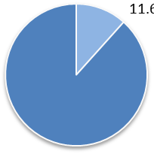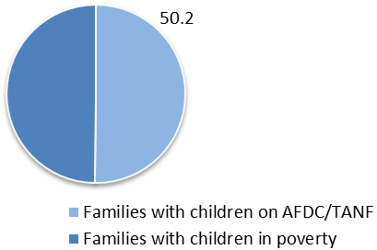

The falling number of families in need that receive support through TANF has led some national experts to question whether the Work Participation Rate is the best way to evaluate state TANF programs. While states may perform well by the measure, it says little about whether families are reaching the overarching goal of becoming economically self-sufficient. Indeed, Mississippi is one few states that have met or exceeded the target WPR of 50%, but is it successful by this standard? Experts have testified before Congress on the matter:

“Mississippi achieved a WPR of 61 percent in 2009, but its employment rate among single mothers (56.7 percent) was among the ten lowest in the country. For every 100 unemployed single mothers, there were just four TANF cases that met their work requirement. Moreover, Mississippi achieved its high work participation rate, at least in part, by serving very few needy families in its TANF program. […] This weakening of the cash safety net for families has contributed to significant increases in the number of children living in deeply poor families and has removed the safety net from the families with the greatest needs — those that have physical or mental health issues and those caring for a sick or disabled child.”[6]

On its face, a high work participation rate and a reduction in TANF caseloads might seem to be positive trends. However, there is a distinction between families that no longer access TANF benefits for some of the reasons noted above versus those that now have quality employment, self-sufficiency, and less of a need for TANF support. As noteworthy as Mississippi’s performance on the WPR is, there is substantial opportunity to advance more TANF families to stable, quality employment and self-sufficiency.

Mississippi can make gains in this regard by improving the provision of vocational education and training in its TANF program, which will help recipients faced with barriers to employment find stable career opportunities that are more likely to lead to lasting security. Mississippi’s high WPR affords the state with the opportunity to still meet the target rate of 50% yet redirect the remainder of the caseload to activities which may not necessarily count towards the measure, including vocational education and training for longer than 12 months or skills learning related to employment. By leveraging its strong performance on the WPR, Mississippi can work within the constraints of federal policy to increase access to vocational education and training opportunities and the success of TANF recipients in these activities in a way that complements a “work first” approach and promotes the workforce development of the state.

# Why Focus on Education and Training in TANF?

Increasing participation in vocational education and training and ensuring students have the resources needed to succeed would benefit both the TANF recipients who participate in these activities as well as the state overall. Workers increasingly need higher educational credentials to be competitive in today’s labor market, particularly when the nation is still in the midst of a slow economic recovery. As illustrated by Figure 2, individuals without a high school diploma or equivalent are nearly three times more likely to be unemployed than those with a bachelor’s degree or higher. Similarly, workers experience substantial increases in earnings with higher levels of educational attainment. Those without a high school credential made $464 in median weekly earnings in 2012, compared with $736 for those with an associate degree or some college, a difference of 59%.

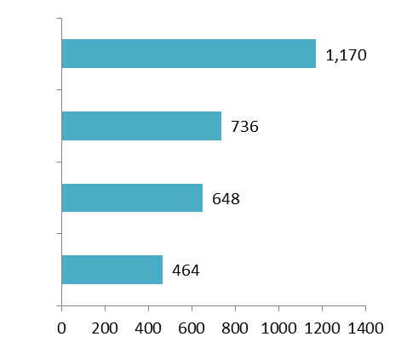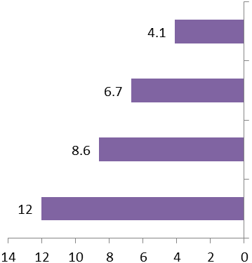

Less than high school diploma

High school diploma

Some College or

Associate degree

Bachelor’s Degree and higher

**Unemployment Rate, 3rd Quarter 2012 (%)**

**Median Weekly Earnings, 3rd Quarter 2012 ($)**

**Figure 2 – Higher Education Improves Economic Security**

Source: Bureau of Labor Statistics, Current Population Survey

In fact, workers with certificates in certain in-demand technical fields can earn more than those with bachelor’s degrees.[7] Certificates can be a cost and time-effective option to becoming more competitive in the labor market for low-income students with barriers to employment and often serve as a stepping stone to earning higher educational credentials.

By improving the employability of TANF recipients so that they are better able to find and keep sustainable jobs, vocational education and training can help lift families out of poverty and lead more stable, productive, and healthy lives.

Improving access to vocational education and training for TANF recipients would also provide significant returns on investment for Mississippi. A workforce development strategy which includes supporting and strengthening vocational education at colleges is beneficial because of the strong connections of such programs to the local labor market. These programs have the flexibility to be more responsive to the changing needs of employers, allowing colleges to teach students the in-demand skills necessary to find work in local industries.[8] By providing TANF recipients and others with the skills to meet these needs, Mississippi can attract new businesses, increase worker productivity, and foster economic growth.

Indeed, metropolitan areas where at least 25% of adults hold such degrees experienced economic growth of 45% between 1980 and 2000, over three times greater than areas where less than 10% of adults had similar educational attainment.[9] Beyond economic benefits, the social returns to investment in postsecondary education, which include increased civic participation and improved health outcomes, are estimated to be as high as 18% when translated into economic value.[10]

Focusing the efforts of Mississippi’s TANF program around vocational education and training is a clear path to better achieving the goals of TANF. Programs that utilize a mixed approach combining job search activities and vocational education and training have resulted in better outcomes in terms of employment and long-term stability than either approach alone.[11] Too much of a “work-first” bent to TANF programs can be counterproductive to helping recipients earn higher educational credentials and find and maintain meaningful employment. Often, the time and administrative requirements placed upon TANF adults make it hard for recipients to successfully juggle work, classes, parenting, and overcoming challenges they may face at home. Due to the complications of balancing work, school, and family, many TANF recipients are unable to continue their coursework or training and thus lose out on the potential benefits of completing these activities.[12]

The rewards at the state and individual level of improving the provision of vocational education and training for TANF recipients becomes even more important when considering the labor market and economic conditions in Mississippi. The sectors with the greatest concentrations of employment in the state include healthcare and social assistance; manufacturing; retail trade; education services; leisure, hospitality and food services; and government.[13] For the next several years, the industries which will experience the most growth include business services, healthcare and social assistance and manufacturing.[14] To take advantage of opportunities within these fields TANF recipients will need to be prepared with the targeted skills and credentials required for growing occupations.

However, data shows that while Mississippi’s labor force has gotten more educated over the last decade, the state’s population with less than a high school diploma or equivalent remains greater than the national average and those with a bachelor’s degree or higher remains significantly lower. These figures are starker when focusing on the disparities that exist between the educational attainment of white and African-American working-age adults and TANF recipients in particular. As Figure 3 shows, most TANF adults have no postsecondary education experience, and over 33% have less than a high school diploma or equivalent. The overwhelming majority (83.3%) of TANF families in the state are African-American.[15]

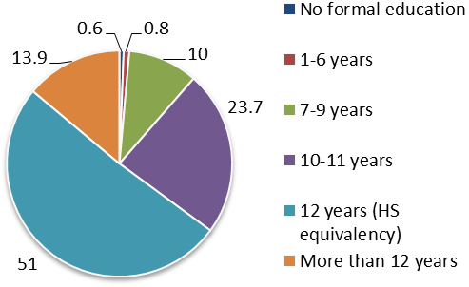

**Figure 3 – The Majority of MS TANF Adults have no Postsecondary Education Experience (%)**

Source: U.S. Dept. of Health and Human Services, Administration of Children and Families, TANF client characteristics by state, FY 2010.

Most of Mississippi’s TANF recipients are young women with children. Finding stable work in jobs that provide living wages has important implications for the well-being of their families and Mississippi overall. Children raised in poverty face emotional, cognitive, physical and academic developmental obstacles which may negatively impact their life outcomes and their employability as adults. When a child later experiences these negative life outcomes, it also costs the state more in aid or other expenses and in attracting businesses. However, children of low-income parents who work *and* receive public assistance earn more when they are older.[16] Given what we know about the likely cost of the status quo and the benefits of a more educated population, strengthening vocational education and training for TANF recipients is a win-win approach for Mississippi’s families and the state’s economy.

# How is TANF Education and Training Currently Delivered in Mississippi and What are Areas for Improvement?

The picture of vocational education and training reveals that Mississippi has the opportunity to better help TANF recipients reach their educational goals. Currently, Mississippi TANF students are served by a combination of Department of Human Services offices, non-profit partners, and the state’s network of community colleges and technical training programs. These resources could form a substantial support system. However, each entity often operates with different requirements, procedures, and staff, making them complicated for students to navigate. Finishing an educational or training program can be particularly difficult for TANF recipients facing various barriers and program requirements, and, as described above, often lacking exposure to postsecondary education systems at all.

Despite their best efforts, many TANF students have been unable to complete their studies because of time limits and other obstacles. Recipients and instructors both become frustrated with current limits. To remedy this frustration, Mississippi can take action to expand education access and improve outcomes for TANF recipients participating in these activities. There are several areas in policy and practice where Mississippi can make changes to promote vocational education and training for TANF recipients while still meeting the federal WPR, strengthening the economic stability of vulnerable families, and promoting workforce development for the state overall.

PRIORITY 1: SHIFTING AWAY FROM WORK-FIRST

Mississippi’s State Plan for the TANF program favors employment as the primary means for transitioning TANF recipients off of the public assistance rolls. The introduction states, “Mississippi's Plan emphasizes family self-sufficiency through full-time private sector unsubsidized employment of all able-bodied adults.”[17] This framework can be problematic based on what we know of the educational attainment of TANF adults given the low likelihood of earning a wage that supports a family. Directing recipients only to work may be detrimental if it overwhelms participants or pushes them to work in jobs without prospects for long-term stability or advancement and narrows the vision of Mississippi’s efforts. Indeed, unsubsidized employment may not be the best focus depending on economic conditions. In December 2012, Mississippi’s unemployment rate of 8.6% was higher than the national average (7.8%), ranking as the 8th highest in the nation.[18] In times such as these when quality employment for TANF adults is hard to find, flexibility or a shift in priorities could benefit TANF recipients and the state alike.

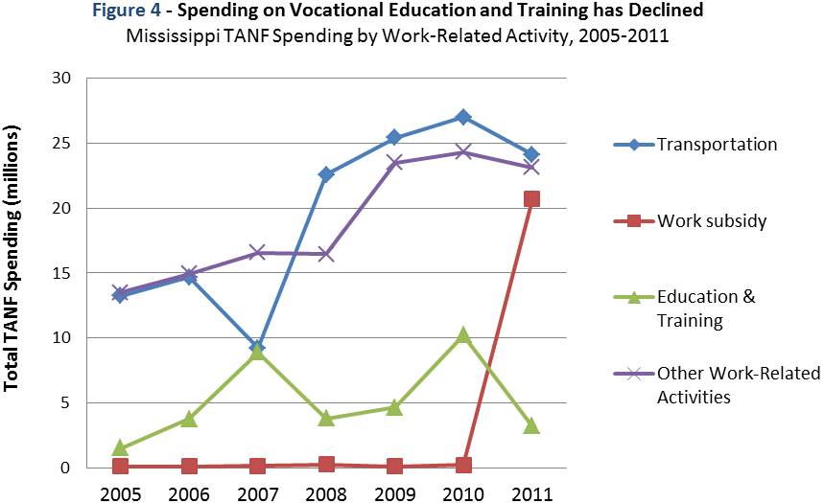

Source: CBPP analysis of state-reported U.S. Department of Health and Human Services data, July 2012.

PRIORITY 2: SPENDING ON VOCATIONAL EDUCATION

Second, a look at the spending of TANF funds in Mississippi indicates that vocational education and training for TANF recipients could be strengthened with increased resources. Despite occasional increases, spending for this category has generally fallen such that spending in 2011 was at its lowest level in five years. Moreover, this category receives very little funding compared to other work-related activities the state spends on with its block grant dollars. At $3,190,049, spending on vocational education and training represented just 4% of Mississippi’s spending of TANF funds for work-related categories in 2011, compared to a national average of approximately 19%. In addition to vocational education representing a small portion of state spending, a participation bonus of $25 maximum a week was discontinued in the summer of 2012.[19] This support was important for recipients in unpaid work activities because it helped cover expenses such as meals or supplemented cash assistance for transportation or necessities like basic utilities. The loss of this resource and the low investment in education and training may contribute to making these activities unfeasible for very low income parents.

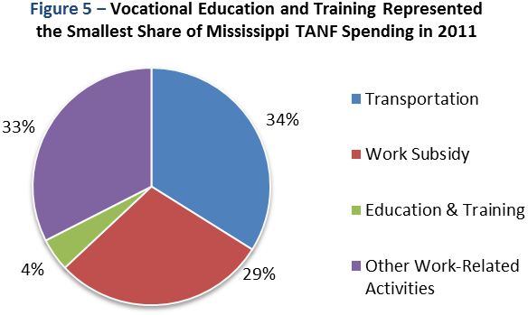

Source: CBPP analysis of state-reported U.S. Department of Health and Human Services data, July 2012.

PRIORITY 3: IMPLEMENT MORE FLEXIBLE STATE POLICY, SO TANF PARENTS CAN PURSUE EDUCATION BEYOND 12 MONTHS

The 12 month time limit on vocational education and training as allowable work activities countable towards the work-participation rate (WPR) also poses a significant obstacle for TANF students trying to obtain a certificate or degree, particularly when college policies do not take into account their circumstances. Take for example the story of Crystal[20], a young mother trying to better her life and the life of her child by pursuing vocational education. She previously earned a certificate in cosmetology but struggled finding consistent work. She returned to school to obtain an associate’s degree in another field, but she discovered remedial courses and courses not essential to her degree were required. When it became clear that she would not complete her course of study within the 12 month time limit and would lack either the time (because of work requirements) or the resources (because of the risk of losing her cash assistance if she continued her classes), she had to withdraw. Crystal’s experience, one shared by many TANF parents, demonstrates how the 12 month limit on vocational education and training is not enough time for adults who need remedial education to earn a postsecondary education credential. Such a limit also restricts the opportunities available to students because the structure of community college courses is often incompatible with TANF program requirements.

PRIORITY 4: DEDICATE MORE RESOURCES TO COMPREHENSIVE CLIENT SUPPORT

A common thread reported by TANF students is the need for more thorough and substantive follow-up by caseworkers regarding barriers identified by recipients upon their acceptance into the TANF program. Barrier screening is meant to reveal problems faced by TANF recipients which may negatively affect their employability, stability, and well-being, as well as their ability to comply with program requirements. However, TANF students indicate more could be done to help them address challenges such as a lack of safe, adequate, and stable housing and childcare for their families. Without strong case management to address client needs, clients are vulnerable to not being able to meet program requirements and struggling to focus on their studies.

PRIORITY 5: RECONSIDER TANF SANCTION STRUCTURE

Sanctions are partial or complete losses of benefits imposed on TANF families for violations of TANF program rules that are intended to encourage compliance and reduce abuse or future violations. The sanction policy in Mississippi’s TANF program poses a significant burden on adults working to complete their education and potentially risks being counterproductive to the goals of the program. Often times the sanction structure is too inflexible to fit the circumstances of different families. For example, a TANF adult may have no more than two excused absences from assigned work activities before facing the possibility of sanctions. Such a limit is less reasonable for a single mother with multiple children, particularly when lacking consistent and adequate childcare necessary for them to attend classes or work. A TANF adult may also receive a sanction for simple infractions such as being slightly late to an appointment with a caseworker or incomplete paperwork.

Mississippi is also one of seventeen states that according to state law practice a full-family sanction, meaning that when an adult TANF recipient receives a sanction for non-compliance, they lose all assistance for their family, including any benefits for their children. Moreover, the sanction can last as long as two months or result in permanent disqualification, depending on the occurrence, and lasts for the time specified or until the recipient falls back into compliance, whichever is longer.[21] Thus, a TANF recipient may correct their non-compliance quickly but would still have to endure a loss of benefits for the required minimum length of the sanction. This policy makes Mississippi’s sanction structure excessively punitive for TANF adults who make good faith efforts to correct non-compliance and places children growing up in poverty in greater hardship through no fault of their own. A single parent pursuing vocational education or training who may be sanctioned because of a mistake or an administrative error would be hard pressed to continue their studies let alone make ends meet under such circumstances.

**Table 1 – Length of Sanction by Occurrence of Non-compliance**

Source: Mississippi State Plan, Temporary Assistance for Needy Families, Mississippi Department of Human Services, October 2008.

|  |  |
| --- | --- |
| **Violation** | **Penalty (whichever is longer)** |
| 1st | 2 months minimum or until compliance |
| 2nd | 6 months minimum or until compliance |
| 3rd | 12 months or until compliance |
| 4th | Permanent disqualification |

# Regional State Models and Best Practices

The Arkansas Career Pathways Initiative (CPI) and the Kentucky Ready-to-Work (RTW) Program are regional examples of state programs that allow current TANF recipients and TANF eligible low-income students to better pursue vocational education and job training. They also represent a culture of promoting higher educational achievement and skill building among TANF recipients as key components of an education-centered approach by their respective state agencies. The following profiles describe these programs and share insights on how Mississippi can take similar action while meeting federal regulations.

While it is important to consider local contextual differences that would affect implementation of such programs in Mississippi, the similarities bode well for successful adaptation. Furthermore, Mississippi can capitalize on its existing strengths and resources, such as the state’s well-recognized community college system and its ties to current workforce development initiatives, to provide integrated support services for this population without building from scratch. By focusing on vocational education and implementing a similar model, the state will help low-income Mississippians better compete for living-wage jobs that will move them to economic self-sufficiency and develop the workforce in growing industries.

***CPI at a Glance***

**Year started:** 2004

**Eligibility:**  TANF recipients and TANF eligible low-income adults

#### Total

**Participants:** 9,397 (FY 2009)

**Annual Cost:** $12 million

(TANF funded)

Source: The Center for Postsecondary and Economic Success at the Center for Law and Social Policy, April 2010.

## Arkansas Career Pathways Initiative (CPI)

The Arkansas Career Pathways Initiative provides academic and support services to low-income individuals to enable them to pursue the educational credentials necessary to attain employment in local high-demand, high wage industries. Interested students must meet regular admissions standards at one of twenty-two community colleges and three technical careers centers where CPI is offered. Once in the program, students first receive a Career Readiness Certificate which indicates they have learned basic skills required for immediate employment. They then select the career option and credentials they would like to pursue from a list compiled by CPI educators.

Throughout their course of study, students work with specially trained on-site counselors and tutors who help them navigate the unique challenges facing low-income individuals (for example, commonly being a first-generation college student and lacking exposure to college registration and financial aid practices) and track their academic progress. This support staff also works with the state workforce development agency to identify and coordinate with other services that may be available to the student including child care and transportation assistance. Struggling students receive individualized instruction to fill in the gaps, and all CPI students retain access to support services after leaving the program, such as resume writing workshops and career counseling.[22]

**Kentucky Ready-to-Work Program**

Created through the state legislature and collaboratively managed by the Kentucky Cabinet for Health and Family Services and the Kentucky Community and Technical College System, the Kentucky Ready to Work (RTW) Program also helps individuals attain educational credentials with a combination of support services and counseling. However, RTW focuses on subsidized work-study placements as a hallmark feature of the program and eligibility is limited to TANF recipients as opposed to the TANF eligible population.

#### *RTW at a Glance*

**Year started:** 1999

**Eligibility:** Recipients of TANF cash assistance

**Total**

**Participants:** About 2,000/year

**Annual Cost:** $10.8 million (FY2010)

Source: The Center for Postsecondary and Economic Success at the Center for Law and Social Policy, January 2010.

The paid work-study placements provide students valuable work experience and the option of more time to earn a certificate or degree. A student’s 20 hour per week work-study placement counts towards the WPR as the core activity “subsidized employment,” after which any coursework can count as the non-core activity “education related to employment.” Thus, students can continue to pursue their studies after their first year of vocational education.[23] Students begin with placements at their colleges or community non-profit organizations to learn basic skills and then complete assignments in a field aligned with their career interests. Students earn between minimum wage ($7.25) and $8.25 per hour, income which they can use to supplement financial aid to pay for tuition and reduce dependence on loans.[24] The highlighted bars in Figure 7 illustrate the added value of education and training for individuals in terms of greater wages compared to other TANF work activities. Such benefits could also manifest for workers in Mississippi, contributing to greater stability for their families and a more robust economy for the state.

RTW also has a sub-program called “Work and Learn” geared toward TANF recipients in adult basic education and GED classes. Work and Learn provides similar services and work-study opportunities, forming a bridge for these students into postsecondary education.

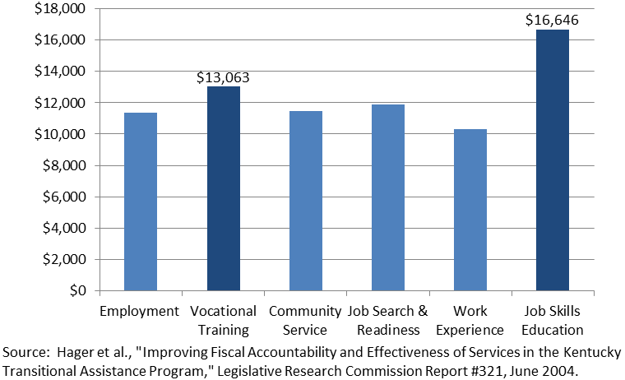

**Annual Wages for those Employed**

**4 Quarters**

**Figure 7 – Education and Training Yields Higher Earnings for TANF Adults**

Earnings by TANF Activity for Kentucky Ready to Work Participants

## Key Takeaways for Mississippi

Incorporating the following lessons from these models into existing frameworks or a new program will advance the workforce competitiveness of the state and improve access to vocational education and training for low-income Mississippians:

* **Pathways to Success are Clear and Flexible**

Arkansas’ CPI pathways model offers its students a variety of entry points which fit the needs of both new workers and incumbent workers who may have lost their job and are looking to retrain to become more competitive in the job market. The variety of credentials, no-credit courses, and for-credit courses allow students to transition smoothly in or out of the program based on their experience level and whether they want to work immediately or achieve a longer term goal. The modularized curriculum also boosts student motivation because the career connections are clear and each step in a pathway leads to a tangible outcome such as a certificate or degree.

* **Work Study Can Expand Education Access and Achievement**

Kentucky’s RTW uses work-study as an innovative strategy to complement a work-first focus while allowing more people to participate in vocational education and training activities for longer periods of time and still count toward the state’s work participation rate. This arrangement allows students to attain degrees that will make them more employable and increase their potential earnings– degrees they may have otherwise been unable to complete if they needed more than the 12 months allowed under federal law.

* **Integrated, On-site Services Bolster Student Success**

Both programs feature on-site counselors who are familiar with the systems and procedures of their respective college campus. These staff members recruit students, help them navigate the financial aid process, connect students to TANF support services such as childcare and transportation assistance, and provide academic support and counseling. Guidance from staff with this kind of understanding is crucial to helping students achieve their goals, keeping program enrollment and retention high.

* **Informed Students Choose Education**

Kentucky law requires that TANF recipients are informed of the option to participate in education and training activities such as the RTW program several times a year. This strong outreach has increased enrollment. Furthermore, another way the RTW program supports an agency-wide culture of prioritizing education is that it facilitates transitions at both ends of its model by recruiting ABE/GED students for its “Work and Learn” component. By exposing students to the program framework and a college environment, the students gain confidence in developing longer-term post-secondary educational goals that will benefit their economic self-sufficiency and form a pool of students prime to participate in RTW.

* **Rigorous Evaluation Increases Accountability and Support**

Both programs have established performance measures which have found the programs to be effective. CPI is independently reviewed in an annual report, the most recent of which found 90% of CPI students completed the program or continued into the next semester. A four year longitudinal study of RTW found that former TANF recipients who participated in vocational education and training activities (the vast majority of which were RTW students) had better entry employment rates, starting wages and continued employment rates compared with former TANF recipients who did not participate.[25] Such findings garner support from the public and government officials and help identify areas for improvement. By tying results to rewards for partner colleges, schools are incentivized to help meet the needs of students in these programs.

**Recommendations**

By strengthening vocational education and training in its TANF program, Mississippi can support the goals of helping vulnerable families achieve self-sufficiency and developing an educated workforce to contribute to the economic vitality of the state. The information known regarding the shortcomings of the work participation rate as a measure of performance, the benefits of increased educational attainment, the needs of Mississippi’s TANF families, and the areas where the state has the opportunity to improve its TANF program all raise the importance of thoughtful, substantive alternatives to the current delivery of vocational education and training services for TANF clients.

The recommendations offered here outline changes in policy and practice aimed at expanding access to education, promoting participation, and improving the achievement and employment outcomes of TANF recipients and of the program overall.

**RECOMMENDATION 1: Mississippi can expand its focus to put greater emphasis on vocational education and training, and reflect this institutional support throughout its TANF program’s policies, culture, and decision-making.** One way the state can do so is by leveraging its high work participation rate to encourage more recipients to pursue education activities. It can continue to meet the target rate of 50% and direct excess cases into vocational education and training through the implementation of programs modeled after those in Kentucky and Arkansas. As described above, these programs utilize subsidized work study placements as a core-activity countable towards the WPR to allow TANF adults the opportunity to continue their studies past the 12 month time limit. By continuing to meet the WPR and using work study placements, Mississippi can advance the postsecondary educational attainment and employability of low-income Mississippians while maintaining the strength of its TANF program and upholding the value of work.

If Mississippi were to enact a TANF work study program, these placements should prioritize opportunities on or near campus to reduce transportation time and cost, making the transition between activities easier for students and maximizing assistance dollars. The state could also form an agreement with community colleges, so they ease their breadth requirements and allow TANF students to focus on the classes necessary for earning their certificate or degree faster. An incentive structure can be created to reward participating colleges according to the numbers of TANF students they serve that successfully attain a credential. Mississippi could also start recruiting more potential TANF students into postsecondary vocational education and training through bridge programs targeting TANF GED students. In any case, close collaboration with colleges is key to shaping programs that effectively serve this population.

**RECOMMENDATION 2: Allocate more TANF funds for education related purposes, such as reinstating participation stipends, where possible.** Investing in vocational education and training is a win-win for Mississippi’s families and the state. Placing greater priority on education is not contradictory but rather complementary to a work centered program. Investment in these activities has the potential to reap benefits in the short and long-term through the increased employability and earnings of TANF adults, the positive impact on the developmental well-being of TANF children, and a more attractive labor pool for businesses.

**RECOMMENDATION 3: Facilitate greater outreach and training to inform caseworkers and recipients of available educational opportunities, and provide institutional encouragement that recipients pursue them.** This can be done partly through developing a more in-depth, integrated, and organic process for completing a TANF recipient’s employability development plan (EDP), which helps guide a client and caseworker through the client’s progress towards self-sufficiency. An EDP created through this process should foster trust, reflect a TANF adult’s skills and interests, and translate them into a path for a career ladder, including education and training opportunities, which are more likely to result in stable and meaningful employment. With enhanced information and communication, a caseworker can be better equipped to provide a TANF client with individualized support to help them on their path. The RTW and CPI profiles above provide excellent examples of such outreach and individualized attention in action.

**RECOMMENDATION 4: Develop a comprehensive plan for addressing the challenges identified by TANF recipients in the barrier screening process.** The process has to move beyond identification to action to help TANF adults with issues of inadequate, unstable, or unsafe housing, domestic violence, and inconsistent childcare. A TANF recipient that can overcome these challenges is likely better able to achieve her education objectives and transition successfully from program assistance. For example, collaboration with homeless service providers to provide transitional or supportive housing or child-friendly policies and facilities at program offices can move TANF families to greater security and allow them to focus on education.

**RECOMMENDATION 5: Reform sanctions policies to ease hardship on vulnerable families and recognize good faith efforts to correct non-compliance.** Rather than a full-family sanction, Mississippi can join other states that enforce sanctions only against the adult portion of a family’s benefits, thereby protecting the children in the household, regardless of their age. It can also be more flexible and responsive in its sanction policy by not requiring minimum sanction lengths beginning at two months. For example, Tennessee reinstates assistance once a family has been in compliance with program regulations for five days. Another option could be to increase the number of allowed absences or other sanction triggers to align with reasonable circumstances facing a TANF parent with multiple barriers. Any one or a combination of these actions would reduce the possibility of a sanction for certain situations beyond a parent’s control, or of a sanction lasting long enough to threaten the fragile stability they are trying to build and that could even inflict hunger upon children. Such reforms would not only help all TANF families get back to making progress towards self-sufficiency sooner, but it could particularly impact TANF adults pursuing vocational education who may fall behind or even have to withdraw from their classes without assistance. An alternative could also be to apply such reforms only to the caseload involved in these activities to incentivize participation and make it easier for TANF adults to reach longer term goals.

# References

1. Finch, Ife and Liz Schott. “TANF Benefits Fell Further in 2011 and are Worth Much Less than in 1996 in Most States,” Washington, DC: Center on Budget and Policy Priorities, November 21, 2011.
2. Ibid.
3. Casey, Timothy. “The Sanction Epidemic in the Temporary Assistance for Needy Families Program,” Legal Momentum: The Women’s Legal Defense and Education Fund. August 2010.
4. Richardson, Philip, Greg Shoenfeld, Susan LaFever, Frances Jackson, “Three-Year Follow-Up Study of Welfare Leavers in South Carolina: Final Report.” Maximus. December 2002. Available at: http://aspe.hhs.gov/hsp/leavers99/state-rpts/sc/3-Year_Follow-Up_Leavers.pdf
5. Center on Budget and Policy Priorities. “Mississippi TANF Caseload Factsheet.” Washington, DC. Updated September 2011.
6. Pavetti, LaDonna. “Testimony of Ladonna Pavetti, PH.D., Vice President, Family Income Support Policy, Before the House Ways and Means Committee, Subcommittee on Human Resources, Hearing on State TANF Spending and its Impact on Work Requirements.” Washington, DC: Center on Budget and Policy Priorities, May 17, 2012.
7. Carnevale, Anthony, Stephen Rose and Andrew Hanson. “Certificates: Gateway to Gainful Employment and College Degrees, Executive Summary.” Washington, DC: Center on Education and the Workforce, Georgetown University, June 2012. Available at http://www9.georgetown.edu/grad/gppi/hpi/cew/pdfs/Certificates.ExecutiveSummary.071712.pdf.
8. Gueron, Judith and Gayle Hamilton. “The Role of Education and Training in Welfare Reform: Policy

   Brief.*”* MDRC, 2002;

   Hamilton, Gayle. “Moving People from Welfare to Work: Lessons from the National Evaluation of Welfare-to-Work Strategies.*”* Washington, DC: U.S. Department of Health and Human Services, 2002. Available at http://aspe.hhs.gov/hsp/newws/synthesis02/.
9. Prince, Heath and Vickie Choitz. “The Credential Differential: The Public Return to Increasing Postsecondary Secondary Credential Attainment.” Washington, DC: Center for Postsecondary and Economic Success, Center for Law and Social Policy, April 2012.
10. 10 Baum, Sandy and Jennifer Ma. “Education Pays: The Benefits of Higher Education for Individuals and Society.” College Board, 2007;

    Wolfe, Barbara and Robert Haveman. “Social and Nonmarket Benefits from Education in an Advanced Economy.” in Yolanda K. Kodrzycki, ed., *Education in the 21st Century: Meeting the Challenges of a Changing World*, 2002.
11. Hamilton, Gayle. “Improving Employment and Earnings for TANF Recipients.” Washington, DC: Urban Institute, March 2012, Brief #6.
12. Ganzglass, Evelyn. “Strategies for Increasing Participation in TANF Education and Training Activities.” Washington, DC: Center for Law and Social Policy, April 17, 2006, p. 6.
13. Mississippi Labor Market Information, Labor Market Statistics, Quarterly Census of Employment and Wages Program, 1st Quarter 2012.
14. Welker, Sarah and Sarah Miller. “State of Working Mississippi 2012.” Jackson, MS: Mississippi Economic Policy Center, 2012.
15. U.S. Department of Health and Human Services, Administration of Children and Families, “Table 8: Active Cases, Distribution of TANF Families by Ethnicity/Race.” *Characteristics and Financial Circumstances of TANF Recipients: Appendix*, Fiscal Year 2010. Available at: http://www.acf.hhs.gov/programs/ofa/resource/character/fy2010/fy2010-chap10-ys-final.
16. Duncan, Greg J. and Katherine Magnuson. “The Long Reach of Early Childhood Poverty.” *Pathways*, Winter 2011. Available at: http://www.stanford.edu/group/scspi/_media/pdf/pathways/winter_2011/PathwaysWinter11_Duncan.pdf
17. Mississippi Department of Human Services. “Mississippi State Plan: Temporary Assistance for Needy Families, October 1, 2008 to September 30, 2010.” Jackson, MS: Revised October 1, 2008. Available at: http://www.mdhs.state.ms.us/pdfs/eatanfsplan.pdf.
18. Bureau of Labor Statistics. “Table 3. Civilian labor force and unemployment by state and selected area, seasonally adjusted.” *Economic News Release.* Updated January 18, 2013. http://bls.gov/news.release/laus.t03.htm
19. Mississippi Department of Human Services. “TANF Work Program Payment Process: Supportive Services.” *Division of Economic Assistance, Temporary Assistance for Needy Families (TANF) Policy. Jackson, MS:* Revised April 04, 2012. Available at: http://www.mdhs.state.ms.us/ea_tanfpolicy.htm.
20. This individual’s name was changed in this report for privacy reasons.
21. Mississippi Department of Human Services. “Mississippi State Plan: Temporary Assistance for Needy Families, October 1, 2008 to September 30, 2010.” Jackson, MS: Revised October 1, 2008, p. 19. Available at: http://www.mdhs.state.ms.us/pdfs/eatanfsplan.pdf.
22. Bone, J. “TANF Education and Training: The Arkansas Career Pathways Initiative.” Washington, DC: Center for Postsecondary and Economic Success, Center for Law and Social Policy. April 2010.
23. Person, Ann, LaDonna Pavetti, and Jeffrey Max. “Providing Paid Employment Opportunities for TANF Participants Engaged in Vocational Education Programs: Examples from Denver, Colorado; Kentucky; and California.” Mathematica Policy Research, Inc., December 2008. Available at: http://aspe.hhs.gov/hsp/08/TANFWPR/1/index.shtml#Abstract.
24. Bone, J. “TANF Education and Training: Kentucky’s Ready to Work Program.” Washington, DC: Center for Postsecondary and Economic Success, Center for Law and Social Policy. January 2010.
25. Ibid.