Undoing Inequity:
Farmers’ Market Nutrition Assistance Initiative
March 2009

Making a Healthy Diet Accessible & Affordable to all Boston Communities

Nico Quintana
for The Food Project

Sponsored by:
The Boston Public Health Commission, The Wholesome Wave Foundation, Farm Aid, Project Bread, Blue Cross Blue Shield, and Mayor Menino’s Fresh Fruit Fund and the Office of Business Development in the Department of Neighborhood Development

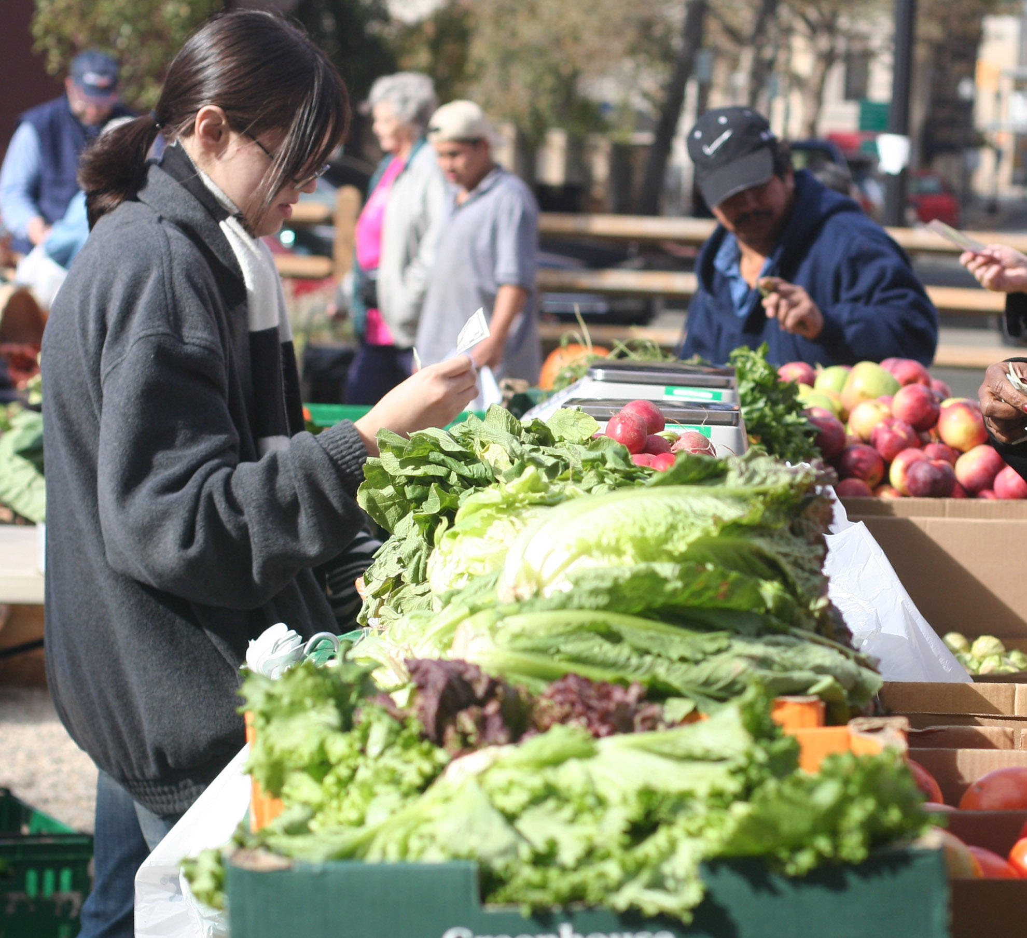

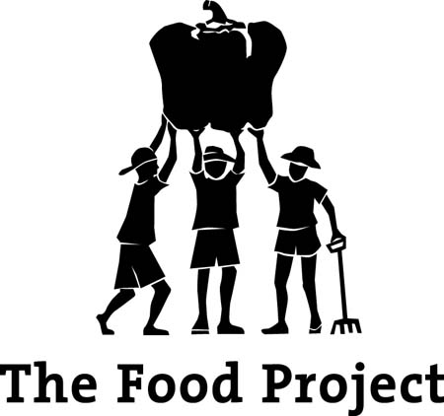

Table of Contents

Terms 3
Executive Summary 5
The Food Project 6
Introduction 7
Boston Health Disparities 8
Access and Affordability: Food Disparities in Boston 9
Boston’s EBT Farmers’ Market Pilot Program 11
Program Assessment 13
Findings: Program Achievements 14
Findings: Program Challenges 16
Modeling Success 18
Improving Boston’s EBT Pilot Program 19
Recommendations 19
Making a Healthy Diet Accessible & Affordable 21
to all Boston Communities
Notes 23

Terms:

WIC: Special Supplemental Nutrition Program for Women, Infants, and Children
SNAP: Supplemental Nutrition Assistance Program (SNAP), formally known as the Food Stamps Program
EBT: Electronic Benefit Transfer, a SNAP program debit card that is used to redeem SNAP benefits
DTA: Department of Transitional Assistance
USDA: United States Department of Agriculture
FMNP: Farmers Market Nutrition Program
SFMNP: Senior Farmers’ Market Nutrition Program
FNS: Food and Nutrition Service, the division of USDA dedicated to federal food nutrition
TFP: The Food Project

Executive Summary
In the summer of 2008 The Food Project launched a Farmers’ Market Nutrition Assistance Initiative designed to reduce food access disparities in Boston in collaboration with Mayor Menino, the Boston Public Health Commission, Wholesome Wave Foundation, Farm Aid, Project Bread, Blue Cross Blue Shield, and the Office of Business Development in the Department of Neighborhood Development. This initiative included several components:
- Providing technical assistance to new Boston farmers’ markets, especially in low-income communities.
- Helping to make eight markets and farm stands Electronic Benefits Transfer (EBT) accessible.
- Piloting Boston Bounty Bucks, an innovative and promising incentive program for EBT use at farmers’ markets.
- Piloting a similar incentive program for users of the Special Supplemental Nutrition Program for Women, Infants, and Children (WIC).
The Boston Bounty Bucks program provides an incentive for Supplemental Nutrition Assistance Program (SNAP, formerly Food Stamp) recipients to purchase fresh local produce at their neighborhood farmers’ markets. The program increases the purchasing power of low-income residents by matching EBT market purchases between five and ten dollars, making the produce of the markets more affordable and providing an incentive for residents to change their purchasing habits to include fresh farm products in order to improve their diets and reduce health disparities in Boston neighborhoods. Boston Bounty Bucks is based on a successful model that has been employed by The Food Project’s Lynn and Dudley Town Common Farmers’ Markets and by the Farmers’ Market Federation of New York.
In addition, The Food Project worked with Mass Farmers’ Markets on a program to provide additional incentives for WIC recipients in areas with historically low WIC redemption rates to redeem their coupons at farmers’ markets. In August, 2008, 8000 green WIC coupons worth $2.50 each were distributed to clients at five Boston WIC offices. The coupons were used as a one-for-one match to the coupons the women were already receiving for themselves and their children.
At the same time, The Food Project supported the creation and expansion of farmers’ markets in low-income communities that accept government nutrition program benefits, such as SNAP, WIC coupons, and senior farmers’ market nutrition coupons. These efforts supported seven new farmers’ markets in 2008 alone.
Early Results
Even though, for a variety of reasons, the initial season of Boston Bounty Bucks did not achieve the anticipated results, we have reason to believe that we have laid important groundwork for future success. We have laid the groundwork to fully implement the program for at least 13 markets in the coming year, and received valuable feedback from customers. In the first year, nine participating markets had a total of $1,310 in sales for the market season; the Boston Bounty Bucks program matched a total of $1,048 dollars of EBT purchases. While this level of participation did not meet the expectations for the program, it is apparent from customer interviews that the pilot program increased consumption of Massachusetts farm products in low-income Boston communities by helping to increase the number of markets in these neighborhoods, and by making these markets EBT and WIC accessible.
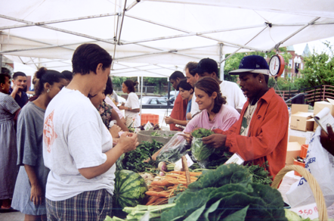
Results of customer surveys and interviews with market managers identified three reasons for Boston Bounty Bucks’ below-expectation sales. First, seven of the markets had technical difficulties with the wireless EBT terminals. The machines were not operational when received, and several of them did not operate properly until September. Second, the Boston Bounty Bucks program did not launch until the end of August because of complications printing the Boston Bounty Bucks banners and coupons. Finally, there was a lack of customer awareness about the incentive program. Minimal publicity about the initiative played a role in this.

The WIC incentive program saw more immediate success: The coupons had a 57% redemption rate according to Mass Farmers’ Markets and accounted for a total of $11,312 in sales of fruits and vegetables. This incentive program may be a reason for an increase in the redemption rate of the regular red WIC coupons that had a redemption rate of 51%, which is a few points higher than in 2007.

Program assessment, including surveys, interviews and focus groups, along with the success of the WIC incentive program, suggests that Boston Bounty Bucks does have the potential to significantly impact the food choices of SNAP and WIC recipients. WIC recipients are far more accustomed to spending their benefits at farmers’ markets (because the program includes coupons specifically redeemable at markets) and, as such, the program was able to have a more immediate impact. We therefore infer that improved awareness and accessibility of the program are key to unlocking this potential.
It should be noted that there is a precedent for EBT promotional programs at farmers’ markets to take several years to begin achieving substantial results. At The Food Project’s Lynn Farmers’ Market, EBT sales have nearly tripled over four years, three of which included some EBT promotion. Likewise, The Farmers' Market Federation of New York reports that food stamp sales at New York farmers' markets increased from $3,000 in 2002 to $90,000 in 2007.

For the 2009 season we anticipate that the following changes will increase the success of the program for both low-income consumers and Massachusetts farmers:
- At least three additional markets will have wireless EBT terminals and participate in the Boston Bounty Bucks program.
- Wireless EBT terminals purchased last year will be returned to be reprogrammed, and a Food Project staff person will be designated to troubleshoot problems and perform outreach at the participating markets in June and July.
- The Food Project and the farmers’ market managers will work with community partners to raise awareness of the program. This will include an ad campaign on MBTA buses and subway cars and promotional materials at neighborhood locations, such as barbershops and hair salons. We will include promotional information in the packages sent to SNAP participants next summer.

Lack of access to fresh produce in Boston’s low-income neighborhoods is a barrier to good health outcomes for residents; these communities do not have access to the food items they need to serve healthy meals to their families. The Boston farmers’ market pilot program was created to bring affordable healthy food into Boston’s food deserts. By helping to improve access to healthy food, the pilot program is working towards building a Boston where all families can have access to fresh local food at affordable prices and where distribution of healthy foods in low-income, urban neighborhoods is financially sustainable for local farmers.

The Food Project
The Food Project works with communities to mobilize resources and develop creative solutions to key challenges facing individuals and cities today: hunger, pollution, lead and pesticide poisoning, and obesity, as well as barriers to diversity, fair wages, community unity, youth empowerment and small-business farming. We believe that food is the common and basic element that links varied people and organizations. The Food Project envisions an improved quality of life for the entire region and nation.
Our mission is to grow a thoughtful and productive community of youth and adults from diverse backgrounds who work together to build a sustainable food system. We produce healthy food for residents of the city and suburbs and provide youth leadership opportunities. Most importantly, we strive to inspire and support others to create change in their own communities.
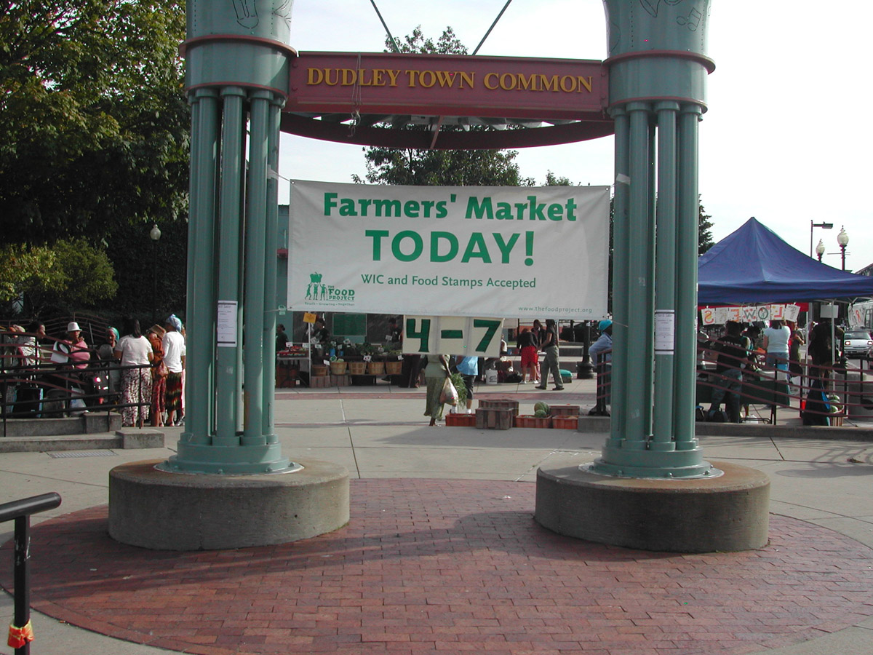
Since 1991, The Food Project has built a national model of engaging young people in personal and social change through sustainable agriculture. Each year, we work with over a hundred teens and thousands of volunteers to farm on 39 acres in rural Lincoln, Ipswich and Beverly, MA and on several farms in urban Boston and Lynn. We consider our hallmark to be our focus on identifying and transforming a new generation of leaders by placing teens in unusually responsible roles, with deeply meaningful work. Each season, we grow over a quarter-million pounds of food without chemical pesticides, distributing at least sixty percent to communities in need through hunger relief organizations and affordable farmer’s markets. We sell the remainder of our produce through Community Supported Agriculture (CSA) crop “shares” and market-rate farmers’ markets. Locally, we also partner with urban gardeners to help them remediate their lead-contaminated soil and grow healthier food. We provide unique capacity building for organizations and educators who learn from The Food Project’s expertise through materials, youth training and professional development opportunities. Even projects completely unrelated to farming can draw on our methods for building inspired, diverse and productive youth communities.
Introduction
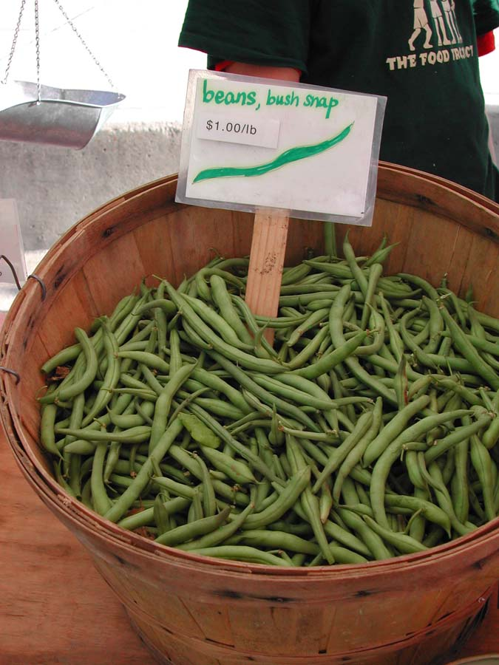
Fresh fruits and vegetables are essential to a healthy life. Throughout the United States, however, many communities do not have access to this basic necessity. Urban food deserts, defined as city regions that are absent of fresh healthy food, are found in low-income neighborhoods, where fast-food restaurants and convenience stores are more common sights than supermarkets or produce stands. In the urban food deserts of our nation, buying fresh, good-quality produce is often impossible for residents without traveling long distances from their neighborhood. As a result, residents of these communities are at higher risk for chronic diseases, such as diabetes and obesity.
The issue of food access has not gone unnoticed, and communities around the United States are mobilizing to rectify the injustice of food disparities by working to make fresh produce available and affordable to low-income communities. One of the most effective ways has been through the creation of farmers’ markets in low-income areas. When paired with federal nutrition assistance program benefits, farmers’ markets are becoming an increasingly important source of fresh, local farm products for urban residents.
Access to healthy food involves not only having healthy food available to purchase from neighborhood venders, but also having the monetary resources to purchase it. Federal nutrition programs, such as the Supplemental Nutrition Assistance Program (SNAP), formally known as the Food Stamps Program, and the Special Supplemental Nutrition Program for Women, Infants, and Children (WIC), help make a healthy diet more affordable to low-income individuals. Congress established the Farmers’ Market Nutrition Program for WIC recipients in 1992, and in 2000, USDA extended this benefit to seniors by creating the Senior Farmers’ Market Nutrition Program (SFMNP). In this program, WIC and SFMNP participants receive coupons to be redeemed at authorized farmers’ markets. WIC clients receive between $10 and $30 in WIC Farmers’ Market Nutrition Program (FMNP) coupons each year. SFMNP clients receive $20 to $50 in coupons each year. The WIC FMNP and SFMNP provide about three million people farmers’ market coupons to purchase fresh vegetables. With limited funding, the WIC and Senior farmers’ market coupons are not the only solution to helping low-income families purchase fresh produce on a regular basis.

The USDA reports that about 29 million Americans use SNAP benefits monthly, nearly ten times the number receiving FMNP coupons, with children making up half of the program participants. Currently 600,000 Massachusetts residents receive SNAP benefits, and an additional 20,000 people apply to the program each month. Prior to the adoption of electronic benefits technology for distributing funds, many farmers’ markets accepted paper food stamp benefits. When the food stamp program switched to Electronic Benefit Transfer (EBT) cards, markets did not have the equipment necessary to take the new EBT cards. As a result, food stamp users were shut out of farmers’ markets, and they lost their connection to this source of fresh, healthy food.
Even when farmers’ markets offer a local source of healthy food in urban neighborhoods, supplemental nutrition programs do not ensure that clients will use food subsidies to purchase healthy food. Healthy and fresh foods can often come with a higher price tag than highly processed foods, which tend to be made from highly-subsidized commodity crops. Government nutrition program clients can benefit from education and incentive programs that encourage them to change their purchasing and consumption habits to include fresh produce in their diets.
Around the United States, many farmers’ markets in low and mixed-income communities are investing the time and resources necessary to make their markets accessible to SNAP participants. In Boston The Food Project, in partnership with Mayor Menino and local health and advocacy organizations, has pioneered a citywide effort to improve food access through Boston’s first comprehensive farmer’s market nutrition assistance initiative.

Boston Health Disparities
Health disparities are defined by The National Institute of Health (NIH) as “differences in incidence, prevalence, mortality, and burden of diseases, and other adverse health conditions that exist among specific population groups in the United States.” Segregation, environmental degradation, poverty, and rising violence, combined with discrimination and racism, are all believed to be contributing factors to health inequities in Boston. However, an additional factor believed to be contributing to health disparities in some City neighborhoods is a lack of access to healthy food.
Segregation is still a reality in Boston, with 92% of black residents living in seven neighborhoods: Dorchester, Hyde Park, Jamaica Plain, Mattapan, Roslindale, and the South End. Sixty-three percent of Latinos live in these neighborhoods as well, and an additional 17% live in East Boston. Additionally, according to the 2000 U.S. census, poverty rates for Asian, Black and Latino Boston residents were significantly higher than for White Boston residents. In Boston, 30% of Asian residents, 22% of Black residents, and 30% of Latino residents live in poverty, compared to 13% of White residents.
In Boston, residents of color have a higher risk of chronic illness and death than White residents. Black residents die from diabetes, cancer, stroke and heart disease at higher rates than White residents. Black residents have a 42% higher chance of premature death than White residents, and Black men have the lowest life expectancy in Boston. Additionally, Latinos in Boston are 2.5 times more likely than White Boston residents to report being unhealthy.
Rates of diabetes and obesity are also higher among Black and Latino residents than White residents, with Black adults in Boston being two times more likely than White residents to have diabetes. Latino Boston residents are slightly more likely that Whites to have diabetes and are more likely to die from it. Additionally, Black adults and Latino youth suffer from the highest rates of overweight and obesity in Boston.

Health Disparities and Diet
According to the Center For Disease Control (CDC), fruits and vegetables have enormous nutritional benefit because they provide valuable vitamins and minerals. The CDC also reports that fruits and vegetables can help to prevent chronic diseases, including “stroke, type 2 diabetes, some types of cancer, and perhaps heart disease.” The CDC advises that eating a balanced diet is essential to maintaining your body's good health. Additionally, The Boston Public Health Commission states: “Diets that are high in sugar and saturated fat have been linked to heart disease, stroke, cancer, obesity, and diabetes,” many of the health conditions prevalent in Boston’s low-income neighborhoods.

Access and Affordability: Food Disparities in Boston
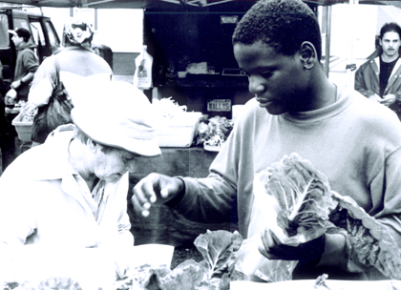
The Boston Collaborative for Food and Fitness (BCFF) was funded by the W.K. Kellogg Foundation in 2007 to do a comprehensive food and fitness assessment of Boston. The BCFF targeted six neighborhoods that were identified by the Boston Public Health Commission as having high rates of chronic disease and obesity: Jamaica Plain, East Boston, Roxbury, North Dorchester, South Dorchester, and Mattapan. Surveys, interviews, and focus groups were conducted in these neighborhoods by local youth-serving, non-profit organizations, and the data was compiled and assessed by P. Kirstin Newby, Assistant Professor at Boston University, and Julia Gittleman, and Tom Mendelsohn from Mendelsohn, Gittleman & Associates, LLC. Based on the results of this assessment, BCFF is currently developing strategies to increase community health and fitness in these six neighborhoods.

Since vegetable consumption is essential to a healthy diet and can help prevent chronic illness, the BCFF asked residents in the six targeted communities about the prevalence of fruits and vegetables in their diets, and about their purchasing habits. Results showed that many residents are not eating fruits and vegetables on a regular basis: 47% of Dorchester residents surveyed, 41% in East Boston , 58% in Jamaica Plain , 42% in Mattapan, and 42% in Roxbury reported that they do not eat vegetables at home.

Additionally, 59% of 574 people interviewed across the six assessment neighborhoods said that the recently rising food prices have affected their household grocery purchases. When asked if they have skipped meals or served fewer vegetables as a result of recent price increases, 17% reported that they skip meals, and 13% said they serve fewer vegetables. Focus groups conducted by Mendelsohn, Gittleman & Associates revealed that people across all six neighborhoods who have cars are commuting out of their neighborhoods to stores where they can buy higher quality food for lower prices.

Food access in low-income Boston neighborhoods
The limited vegetable consumption by residents of low-income communities in Boston is due to several factors, including lack of access to grocery stores that carry fresh produce and the relatively high cost of fresh vegetables. The report The Real Cost of a Healthy Diet: Coming Up Short: High Food Costs Outstrip Food Stamp Benefits, published in 2008, can help explain why low-income Boston residents are not regularly eating fruits and vegetables.
The Real Cost of a Healthy Diet was a project of C-SNAP at Boston Medical Center & The Philadelphia Grow Project at Drexel University. The project examined whether low-income residents in Boston and Philadelphia could purchase healthy food from their neighborhood stores with a budget equal to the maximum food stamp benefit allotment. The Thrifty Food Plan is a food plan with a shopping list and menu plans for a healthy diet at a minimal price. In 2006 the USDA made revisions to the plan for the first time since 1999 and issued an updated report in 2007. The cost of the new 2007 Thrifty Food Plan guides national nutrition policy in the United States, including the maximum food stamp allotment. Food stamp allotments do not vary according to regional differences in the cost of food, even if the cost of food in cities is more expensive than the cost food in the suburbs or in rural communities. The Real Cost of a Healthy Diet investigated whether the 2007 Thrifty Food Plan could be purchased in Boston within the budget of the current maximum food stamp benefit.

In this study, researchers visited 16 stores in four low-income Boston neighborhoods, from large supermarkets to small corner stores, to see what items they carried and at what prices. The project reported that in Boston, families receiving the maximum food stamp allotment of $542 a month could not afford the cost of the Thrifty Food Plan. The study revealed that Boston families would have to spend an additional $210 a month to purchase the plan. Of the 104 items on the Thrifty Food Plan, 16% of the items were not available in inspected Boston stores. The most commonly missing items were the most nutritious and vitamin-rich items on the list, including fresh fruits and vegetables, whole grains, low-fat dairy products, and lean meats.
Boston’s Farmers’ Market Nutrition Assistance Initiative
In the summer of 2008, The Food Project, in collaboration with Mayor Menino and local and national partners, launched the Boston EBT Farmers’ Market Pilot Program. This pilot program was designed to increase the availability of fresh fruits and vegetables in low-income communities in Boston by supporting the creation and expansion of farmers’ markets that accept government nutrition program benefits, such as SNAP, WIC coupons, and senior farmers’ market nutrition coupons. The program provided both new and existing urban farmers’ markets with wireless EBT terminals, financial assistance, and staff advisory support. The program also addressed the affordability of fruits and vegetables by offering an incentive program, Boston Bounty Bucks, for residents that use federal food assistance funds to increase the buying power of their food dollars. This program offers an incentive for residents to change their purchasing habits to include fresh farm products in order to improve their diets and eliminate health disparities in Boston neighborhoods.

Pilot program communities
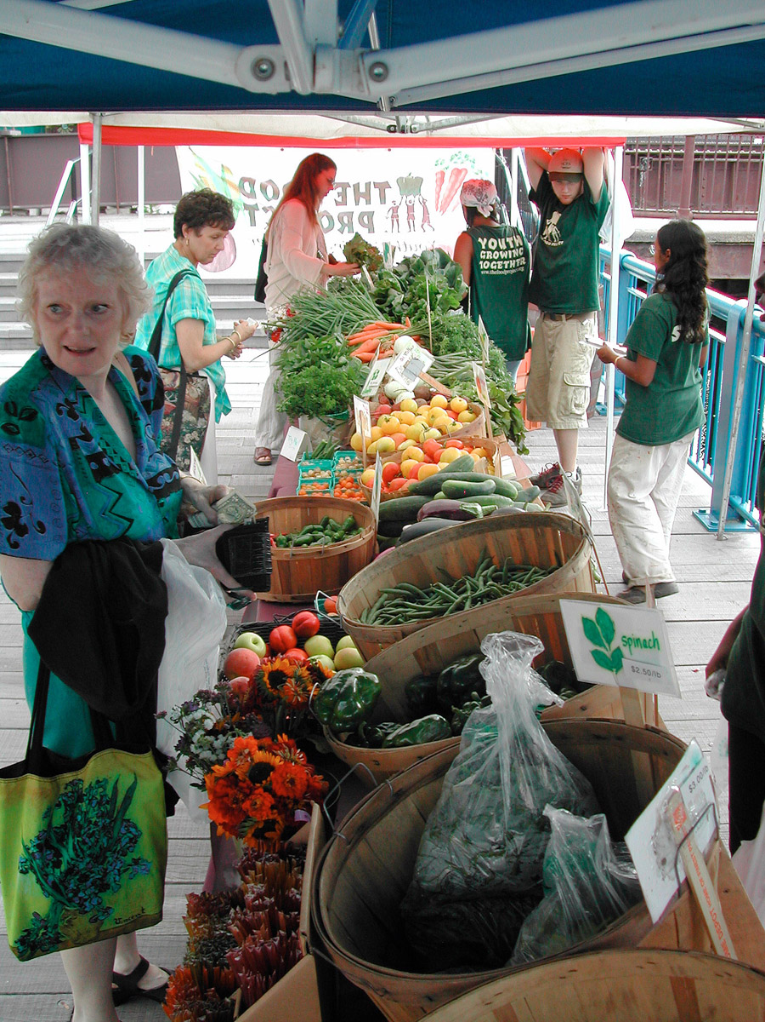
The pilot program included the six Boston neighborhoods studied by the BCFF (East Boston, north and south Dorchester, Roxbury, Jamaica Plain, and Mattapan) as well as Allston and Roslindale. The Food Project worked with local health centers and community members in each community to bring ten markets into the program. Seven of these markets were new in 2008, and three were previously established. The participating markets included: Allston Farmers’ Market, Boston Medical Center Farmers’ Market, Bowdoin Street Farmers’ Market, Dudley Town Common Market, Dorchester House Farmers’ Market, East Boston Farmers’ Market, Mattapan Farmers’ Market, Mission Hill Farmers’ Market, Revision House Farmers’ Market, and Roslindale Farmers’ Market. The Food Project’s Dudley Town Common Market was the only market with the capacity to accept EBT prior to the summer of 2008.
Pilot program history
The creation of the EBT pilot program began with the mobilization of potential markets. Food Project staff worked to bring farmers, market managers and potential customers to the table to convince all parties involved that an EBT program would benefit both farmers and consumers. Ten markets opted to participate in the program, and The Food Project staff worked with them to help prepare them for the 2008 market season. In addition to hosting an information session in January 2008 and an EBT training session in May 2008, The Food Project provided each market with staff support throughout the market season and a farmers’ market manual that included instructions on how to apply to become a certified EBT and WIC vendor.
Each market had a market manager, and each market manager worked to bring farmers and clients to their market. Market managers were also responsible for applying for EBT and WIC vendor status. All markets in the program submitted a USDA Food Stamp application and received authorization to accept food stamps. Most of the markets were authorized by June; however, the Mattapan farmers’ market did not receive authorization until September. The Revision House market’s certification was delayed until October due to complications with their type of market, which is classified as a “farm stand” as opposed to a “farmers’ market.”
TFP purchased EBT terminals for the markets; the terminal service provider offered training by phone for market staff on how to use the terminals. Six Nurit 8010 wireless terminals capable of processing EBT purchases were purchased for use by pilot program markets for the 2008 market season. The Food Project selected Sage Bank/Merchant Services as the service provider for the EBT terminals based on a cost comparison with other service providers and the recommendation of market managers in other cities. The machines were purchased at half the price of an average machine. The EBT machines were distributed to all pilot program markets, with the exception of Allston, Boston Medical Center, and the Dudley markets. The Allston market and the Dudley market had previously purchased their own machines, and the Boston Medical Center’s market was able to share a wireless EBT terminal with the Bowdoin market because The Food Project staff ran the terminal at both markets.
The Food Project worked with community members and key stake holders to design Boston’s first EBT incentive program, called the Boston Bounty Bucks Pilot Program. TFP wrote and submitted a proposal to the USDA for authorization to implement an incentive program for SNAP benefits customers. Permission to run a pilot program was received in July, on the condition that all markets use both market scrip and Boston Bounty Bucks coupons.
Each market was asked to publicize the EBT pilot program to its customers. At each market, there were signs posted about the market to inform customers that the market accepted WIC and EBT. All markets were supplied with a large banner that was created and supplied by the Office of Business Development in the City of Boston’s Department of Neighborhood Development as well as the Boston Bounty Bucks coupons; they were asked to make their own market scrip to hand out to customers. Markets that had more than one vendor would hand out both scrip and Bounty Bucks coupons to customers after swiping their EBT cards for the requested amount; customers used both the scrip and coupons to make food purchases at the market. At the close of the market, managers would reimburse farmers for all the scrip and coupons they had taken in during the market.
WIC and EBT incentive programs:
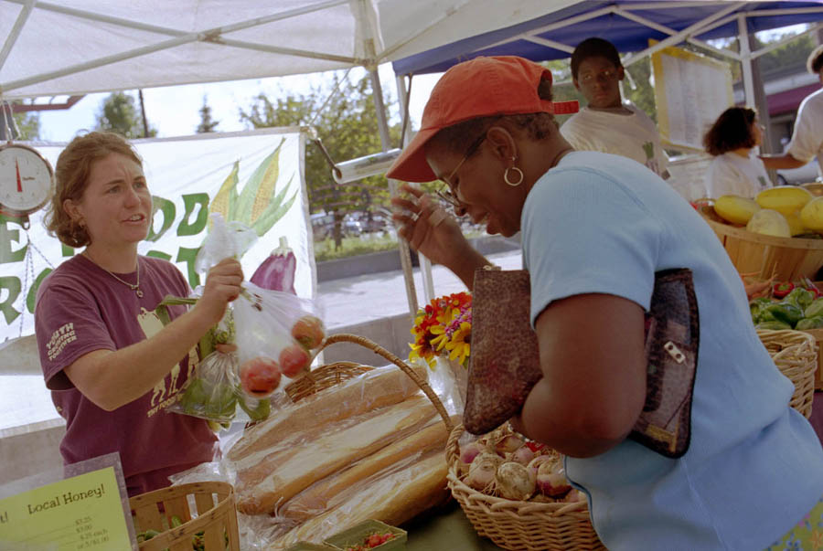
In preparation for the opening of the program in the summer of 2008, The Food Project, in partner with the city of Boston, raised a total of $50,000 to support the EBT and WIC incentive programs. The Boston Bounty Bucks program was given $20,000 of funding, and the WIC incentive program was given $20,000 of funding. $10,000 of funding was kept as a reserve in case either program exceeded its budgeted amount.
The Boston Bounty Bucks program provided an incentive for SNAP recipients to purchase fresh local produce at their neighborhood farmers’ market. It was modeled on a similar SNAP incentive program initiated by The Food Project’s Lynn, MA and Dudley Town Common Markets in 2007. This model has also been used in other communities across the country. Boston Bounty Bucks matched EBT farmers’ market purchases between five and ten dollars with coupons of equal value, making the produce of the markets more affordable for low-income residents. Each market was allocated $1,500 for matching coupons.

In addition, The Food Project worked with the Federation of Massachusetts Farmers’ Markets (FMFM) on a program to provide additional incentives for WIC recipients to redeem their coupons at farmers’ markets. In August, 2008, 8,000 green WIC coupons worth $2.50 each were distributed to clients at five Boston WIC offices with historically low WIC redemption rates. The coupons were a one-for-one match to the coupons the women were already receiving for themselves and their children.

Program Assessment
The Boston Farmers’ Market Nutrition Initiative was assessed in the fall of 2008. The goal of the assessment was to see what impact the programs had on increasing food access in the target program communities and how it could be improved in 2009.
The assessment consisted of farmers’ market manager interviews, market site visits, stakeholder interviews, and customer surveys. A total of 15 interviews and 50 surveys were completed. The customer surveys are a convenient sample and were conducted in both English and Spanish at six different market sites. The majority of the surveys completed were from markets in Dorchester and Roxbury.
The questions in the customer surveys focused on whether customers noticed a change in their health or diet since shopping at the farmers’ market, and whether having WIC and EBT access at the market helped increase their access to healthy food. Questions were also asked about customer awareness of EBT access and the Bounty Bucks program. The market manager interviews focused on their perceived market successes and areas for improvement. Questions addressed EBT machine performance, EBT market system, and publicity. The future plans section of this assessment was based on a focus group meeting discussion that included market managers, community members, and key stakeholders.
Although this is not a scientific assessment of the program, it does provide insight into which areas of the program can be improved to increase participation.
Findings: Program Achievements
From the interviews and site visits, it is apparent that the pilot program increased access to fruits and vegetables in low-income communities in Boston by to increasing the number of low-income markets in Boston, and making these markets EBT and WIC accessible. Farmers’ market customers reported that the markets increased their access to fresh food and their ability to serve nutritious meals to their families.
Seven out of the ten markets were EBT accessible.
The markets participating in this initiative had a collective total of $1,310 in EBT sales for the market season; the Boston Bounty Bucks Program matched a total of $1,048 of EBT purchases. Although this level of usage did not meet the expectations for the program, it is important to acknowledge the significant technical challenges related to EBT machines, which affected overall sales. Three of the ten markets had zero EBT participation, and only one market had more than $500 dollars worth of EBT sales. Although EBT sales were low, the program managed to increase the number of markets with EBT machines in Boston, from one to seven in the span of a year.

Program markets increased fruit and vegetable consumption in Boston.
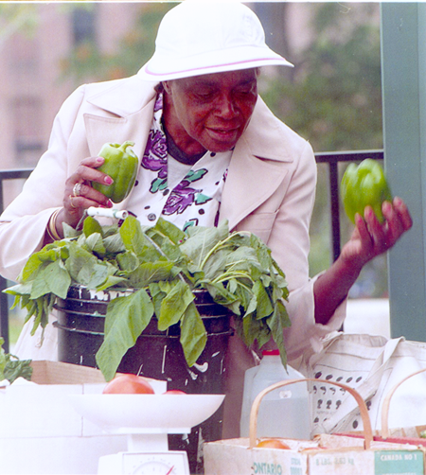
Customers reported that the pilot program increased their access to fresh vegetables. From a convenient sample gathered at Dorchester and Roxbury markets, 96% of the 50 individuals surveyed stated that their local farmers’ market made it easier for them to buy fresh fruits and vegetables. Every one of these customers was using Nutrition Assistance Programs—five were EBT customers, and 45 were WIC customers. Additionally, 98% of customers surveyed reported that using their WIC or EBT benefits at the markets allowed them to serve more nutritious meals to their families. Further, 96% stated that their families were eating more fruits and vegetables since they began shopping at the market. All five of the EBT customers reported that Boston Bounty Bucks made a difference with their food budget.
WIC incentive program may have helped increase market participation.
The majority of the participating markets worked in close partnership with local WIC offices. WIC farmers' market coupons, Senior Farmers’ Market Nutrition Coupons, and WIC incentive coupons were accepted at all of the farmers' markets in the pilot program. From the customer surveys conducted in Dorchester and Roxbury, 45 out of 50 people said they came to the market because of their WIC coupons. All of these customers had the regular WIC coupons.

As stated previously, in August of 2008, 8,000 green WIC incentive coupons were distributed to five Boston WIC offices with historically low WIC FMP redemption rates in an effort to increase participation. Food Project staff worked with FMFM to implement this program. The incentive coupons had a 57% redemption rate and accounted for a total of $11,312 in sales of fruits and vegetables, which went directly to Massachusetts farmers. This incentive program may be a reason for an increase in the redemption rate of the regular red WIC coupons to 51%, which is a few points higher than in 2007. The increase of WIC redemption rates could also be a result of higher food prices at local stores or the fact that seven new farmers’ markets opened in Boston in 2008, increasing the convenience of shopping at this venue. Additional information is needed from the WIC offices to determine whether the incentive program was responsible for the WIC redemption increase.

Findings: Program Challenges
Faulty EBT machines significantly reduced EBT sales.
The pilot program had significant problems with the EBT machines purchased from Sage Bank/Merchant Services and distributed to eight out of ten markets. All market managers who received an EBT machine from the program had technical difficulties with the machine. The machines were not operational when received, and managers had to devote a significant amount of time and energy to making the machines operational. The majority of the markets had their EBT machines replaced more than once, and all reported that both the Sage Bank and Merchant Services were difficult to work with and unresponsive to technical problems.

Although all of the markets with program-purchased machines experienced technical difficulties, most markets managed to resolve the technical difficulties by the end of August. These markets were Mission Hill, East Boston, Bowdoin/Geneva, BMC and Dorchester House, although all reported a loss of sales due during the period when the terminals were not functioning properly. The market managers of the Bowdoin/Geneva Farmers’ Market and Dorchester House Farmers’ Market both reported that they gave free produce when an EBT purchase could not go through due to technical difficulties. While these giveaways fell outside the parameters of the project, the managers felt that they were critical to limit customers’ disappointment and to encourage them to return. The markets were reimbursed for the costs they incurred with these giveaways.

Three markets did not have a single EBT transaction during the 2008 season: Revision House Farmers’ Market, the Mattapan Farmers’ Market, and the Roslindale Farmers’ Market. The Revision House Farmers’ Market did not get its authorization until October and was not able to accept EBT before the end of the season. The Roslindale Farmers’ Market manager left in mid-August before the EBT terminal problems had been corrected, and a new manager was not hired for several weeks. She was not interested in participating in the program while she was adjusting to her new job. The Mattapan Farmers’ Market made a valiant effort to make its EBT machine operational but was unable to resolve the difficulties until the very last market day. It is also important to note that the Allston Market’s did not have technical difficulties. This market purchased its own EBT machine at the beginning of the 2008 market season, yet had low overall market attendance due to inadequate outreach and publicity.
Lack of advertisement adversely effected EBT sales.
Many of the farmers’ markets had low EBT sales, which resulted in large part from a lack of customer awareness about the EBT and Boston Bounty Bucks program. Minimal publicity about the program played a role in this. Although every market received a banner provided by the city, market managers reported that the size of the banners made it difficult to use as an effective advertising tool. Additionally, onsite signs and banners only advertise to those already at the market. They cannot replace the efficacy of a comprehensive advertisement campaign.

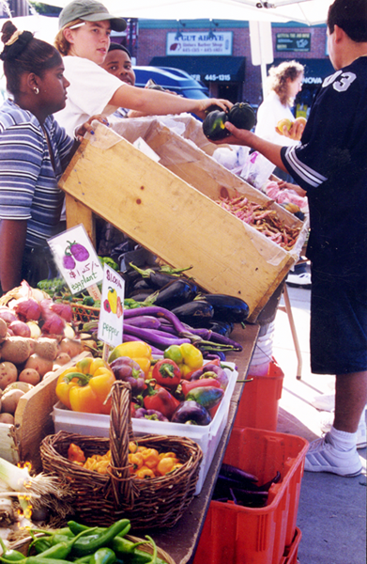
Out of 50 individuals surveyed at the Dorchester and Roxbury markets, only two knew that the markets took EBT, and only one knew about the Boston Bounty Bucks Program prior to that day at the market. All of the individuals surveyed suggested that more advertisement was needed. One customer at the Dudley market said that “people would come if they knew about it.”
Despite not having resources available for a comprehensive advertising campaign, many of the markets had creative ways of advertising their market and their market’s incentive programs. Bowdoin/Geneva Market managers dressed up as giant vegetables to draw the public’s attention to the market. The Mission Hill Market posted an advertisement in the local Mission Hill Gazette twice during the season, sent out monthly emails to its listserv, and distributed flyers to local building complexes and public areas, such as the library, the community center and coffee shops. Many markets worked with local WIC offices to get the word out. The Dudley Town Common Market reported that its intensive word-of-mouth campaign was effective in getting new customers to the market by reminding every customer that the market accepted senior coupons, WIC, and EBT, and that the market was offering a special EBT incentive program called the Boston Bounty Bucks.
The EBT market system was not accessible for non-English speaking customers.
From six site visits, and ten market manager interviews, it became apparent that the process for making an EBT purchase at a farmers’ market from a central terminal was not clear and accessible to some customers. When a customer came to purchase produce with an EBT card from a market, the majority of markets would give that customer two kinds of market currency (market-specific scrip and a Boston Bounty Bucks coupon) to purchase produce from farmers. This system which was mandated by USDA, proved to be confusing for customers, especially those with limited English language proficiency. In two incidents observed during the assessment study, non-English-speaking women became upset and confused when they were handed two kinds of market currency. Even English-speaking customers stated that the process could have been explained better.
Farmers’ market managers had difficulty recording EBT sales.
Market managers reported that handing out both market scrip and Bounty Bucks coupons was confusing for them as well as farmers. Since each market was responsible for keeping track of its own EBT operating costs, transaction fees, and Boston Bounty Bucks distribution numbers for reimbursement, having two kinds of market currency made it more difficult to record accurate sales data.
Due to generous support from key funders, The Food Project was able to designate funds to reimburse all markets for charges associated with the wireless terminal, and for the entirety of the Boston Bounty Bucks matching program. Market managers were responsible for invoicing The Food Project for related expenses. Individual farmers were reimbursed at the end of each market day by the market manager, and were paid for the amount of market scrip and Boston Bounty Bucks dollars they collected during the day. Although each market manager was responsible for invoicing The Food Project for all EBT expenses, many markets did not follow through with this responsibility. When asked about why they had difficulty with turning in the invoices, some market managers mentioned that the forms to record the market data were too complicated. Other market managers said that they were not clear about which charges were reimbursable.

A Model with Great Potential
All over the country, Farmers’ Market EBT programs are working to improve food access in low-income communities, with 46 states now having at least one farmers’ market accepting EBT. In spite of a difficult pilot season, we are confident that this initiative has the potential to have a significant impact on consumption of fresh, local vegetables in these communities.
From The Food Project’s own experience pioneering the approach in Massachusetts and a survey of successful programs in nearby states, it is apparent that it takes time to build an effective EBT program. At The Food Project’s Lynn Farmers’ Market, EBT sales have nearly tripled over four years, three of which saw the use of some form of EBT promotion.

According to an article by Valerie Bauman in the Associated Press, New York State’s EBT Farmers Market Program took several years before it had made substantial EBT sales. In 2007, 40 markets in New York State accepted food stamps. In 2008, 87 of about 400 markets in New York State accepted EBT. The Farmers' Market Federation of New York reports that food stamp sales at New York farmers' markets increased from $3,000 in 2002 to $90,000 in 2007. The New York State Program has an advertisement strategy and an incentive program called NY Fresh Checks, which is very similar to Boston’s Bounty Bucks, giving EBT customers $5 incentive coupons for spending a minimum of $5 on their card.

Under the New York Farmers' Market Wireless EBT Program, market managers are given a wireless EBT terminal, 1,000 EBT market tokens, EBT ledgers to record sales, a banner to put on the EBT sales booth, and EBT technical training. An advertising packet is also provided with educational materials in both English and Spanish. The packet also includes a promotional poster, press releases, a handful of paper ads, a customer brochure, and advertisement instructions. With fully functional machines and an advertising strategy, the New York program continues to grow.
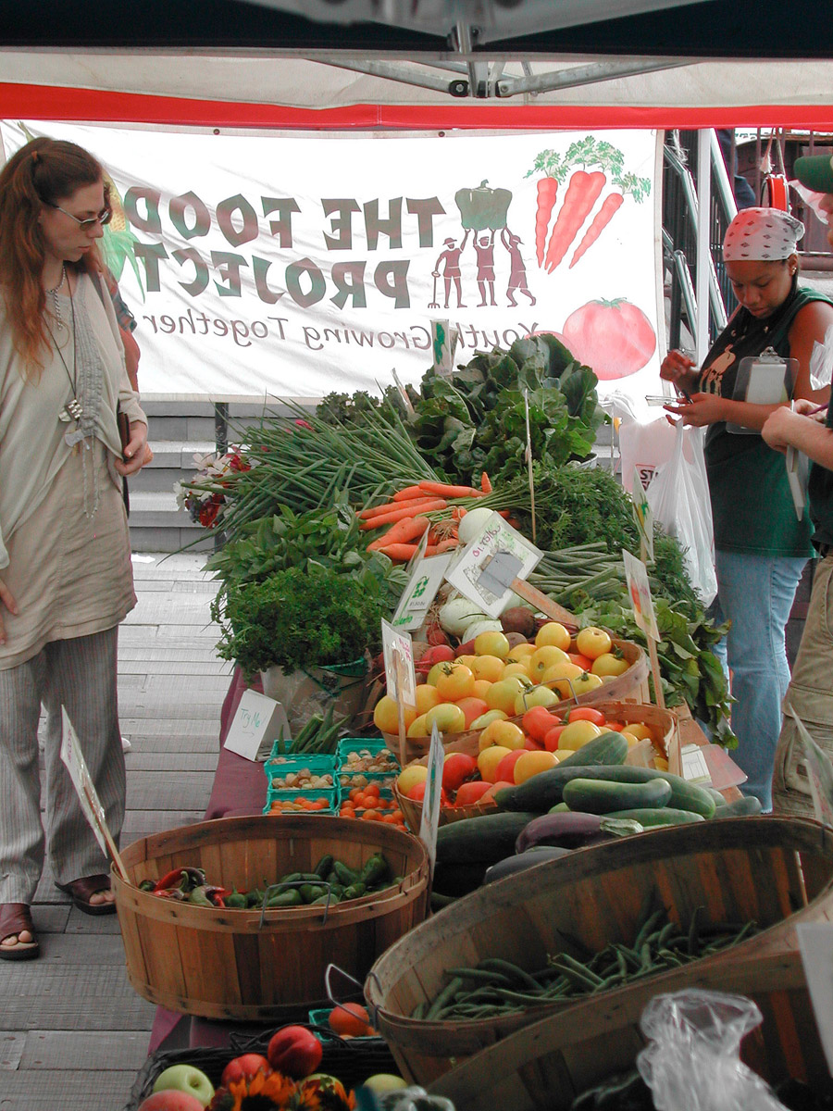
Improving Boston’s EBT Pilot Program
From customer interviews, it is clear that the increase in the number of markets accepting EBT and WIC in Boston has increased access to fresh produce, and that it has the potential to do even more in the coming years. It is also clear from the surveys that the families of those interviewed are eating more fruits and vegetables since they began shopping at a farmers’ market. The majority of customers surveyed said that using their WIC or EBT benefits at the market has helped them serve more nutritious meals to their families. Customers reported that more people would use their EBT benefits at the market if they knew about it. Slight increases in the WIC participation rate suggest that the WIC incentive program may have helped to increase WIC coupon redemption rates.
Looking at the success of the Dudley market and the New York Farmers’ Market Program, there is no doubt that the Boston program can significantly increase EBT participation by improving certain aspects of the program, such as EBT machine reliability and promotion. Past performances at the Lynn Farmers’ Market and Dudley Town Common Market suggest that the EBT incentive program can help increase general market participation as well.

Planned Improvements
The majority of farmers’ markets in the new pilot program struggled with three main challenges: getting the wireless terminal to function properly, developing an easy-to-use and efficient transaction system for EBT and Boston Bounty Bucks, and getting EBT customers to their markets.
Improve EBT terminal reliability and functionality.
The EBT terminals used at the majority of the farmers’ markets were unreliable. The machines broke down regularly, and had to be replaced in some instances up to three times. Additionally, many of the market managers reported that the EBT service provider did not respond to their technical support questions in a professional or timely manner.
The old machines will be sent back to the company to be reprogrammed and a new service provider will be selected. To prevent the technical malfunction from affecting sales in the 2009 market season, the machines should be tested several months prior to the start of the season.
Invest in EBT training.
To familiarize market managers with the machines, each market will receive in-person EBT training from The Food Project before the start of the market season. Each market manager will be given an easy-to-read market guide that includes information on how to troubleshoot the EBT terminal and numbers to call in case of technical malfunction. Additionally, in the beginning of the 2009 season, a market EBT machine expert will be designated to help market managers with technical questions related to their EBT terminal.
Simplify the market system.
As required by the USDA during the 2008 market season, markets gave customers two kinds of market currency to buy groceries from farm vendors: the market scrip, and the Boston Bounty Bucks coupons. This proved cumbersome for the market managers and confusing for the customers and farmers.
For the 2009 market season, we are working with the USDA to establish a plan for all markets to use only one form of market currency. Boston Bounty Bucks, which were printed for all of the markets in large amounts this past year, will become the currency used by all program markets. With this system market managers will still have to record the EBT transaction and the Boston Bounty Bucks matching amount separately, but they will only give out Boston Bounty Bucks coupons for market currency. Each market will have an EBT booth with a ledger book next to the machine to record all EBT sales and Boston Bounty Bucks distributed. This booth will be towards the middle of the market and away from walls to get the best wireless reception.
Change minimum allotment for Boston Bounty Bucks.
The Boston Bounty Bucks allotment will be changed. Instead of the old system, which was confusing to calculate due to minimum requirements, the new system will simply reduce all EBT customer bills in half with a maximum matching benefit of $10. For example, if a customer brings $20 worth of produce to check out, his or her EBT card would be debited for $10.
Implement a comprehensive marketing and advertising campaign:
For 2009, a comprehensive advertising campaign will be launched prior to the market season to help build awareness of the program.
This will include:
- Distributing fliers about Boston Bounty Bucks with material distributed to SNAP participants by the Department of Transitional Assistance.
- Distributing posters at the DTA offices and SNAP screening centers with pull-off tabs.
- Creating fliers, posters, and brochures in multiple languages to distribute in barber shops and salons and post on buses and the T.
- Writing press releases for local newspapers.
- Advertising in local housing magazines.
- Utilizing local radio stations to advertise about the program.
- Advertising in local church bulletins.
- Speaking with local Head Start centers, health centers, and WIC offices to advertise to their client bases.

Making a Healthy Diet Accessible & Affordable to all Boston Communities

The Boston EBT Farmers' Market pilot program set out to increase food access in low-income neighborhoods in Boston. Despite initial technical complications, the program was able to increase the number of farmers' markets in the city, and to support the implementation of the Boston Bounty Bucks and WIC incentive programs at ten markets. With continued support and increased funding, this pilot program will be able to expand its promising model to additional sites throughout Boston, and help increase EBT participation among low-income Boston residents. In 2009 the program plans to expand to several established farmers' markets that do not currently have EBT access, such as South Boston and Codman Square, and to newly established markets, such as the one proposed for the Ashmont T Station.

Making healthy food available and affordable to all communities in Boston is essential to improve public health, and to undo deeply entrenched inequities. Boston communities are in need of healthy food, and the Farmers’ Market Nutrition Assistance Initiative can help bring that food to the table.
NOTES

Benjamin Fried “For the Health of It: Farmers markets boost the prospects of low-income communities with fresh, wholesome food,” Oct. 2005, Feb. 2008 <http://www.pps.org/info/newsletter/october2005/markets_health>
Fried
Fried
Rachel Wench, “National Incentives at Farmers’ Markets: Brining Fresh, Healthy, Local Foods With in Reach,” Oct. 2008, 8 Feb. 2008, 6. <http://www.farmersmarketcoalition.org/wpcontent/uploads//2008/12/ebt_matching_programs_rachel_winch.pdf> Report also available from: RachelWinch@freshfarmmarket.org.
United States Department of Agriculture, “WIC Farmers' Market Nutrition Program,” Aug. 2008, Feb. 2008 <http://www.fns.usda.gov/wic/WIC-FMNP-Fact-Sheet.pdf>
United States Department of Agriculture, “Senior Farmers’ Market Nutrition Program (SFMNP),” Oct. 2006 <http://www.fns.usda.gov/cga/FactSheets/SFMNP_Quick_Facts.htm>
Wench 7.
United States Department of Agriculture, “Leading the Fight Against Hunger: Federal Nutrition Assistance”, USDA FNS, June 2008, Feb. 2008 <http://www.fns.usda.gov/fncs/hunger.pdf; USDA SNAP website at http://www.fns.usda.gov/fsp/>
Boston Public Health Commission, “Mayor’s Task Force Blue Print: A plan to eliminate racial and ethnic disparities in health,” Jun. 2005, p. 6. <http://www.bphc.org/director/pdfs/blueprint/blueprint-intro.pdf>
Boston Public Health Commission, “Mayor’s Task Force Blue Print,” 10.
Boston Public Health Commission, “Mayor’s Task Force Blue Print” 11.
Boston Public Health Commission, “Data Report: A presentation and analysis of disparities in Boston. Boston, Boston Public Health Commission,” Jun. 2005, p. 14. <http://www.bphc.org/director/pdfs/datareport/datareport.pdf>
Boston Public Health Commission, “Data Report,” 14.
Boston Public Health Commission, “Data Report,” 8.
Boston Public Health Commission, “Data Report,” 1.
Boston Public Health Commission, “Data Report,” 19.
Boston Public Health Commission, “Data Report,” 20.
Boston Public Health Commission, “Data Report,” 35.
Boston Public Health Commission, “Data Report,” 28.
Boston Public Health Commission, “Data Report,” 37
Boston Public Health Commission, “Data Report” 30, 38.
Center for Disease Control, “Fruit and Vegetable Benefit,” Feb. 2008 <http://www.fruitsandveggiesmatter.gov/benefits/index.html>
Center for Disease Control, “Fruit and Vegetable Benefit,” Feb. 2008 <http://www.fruitsandveggiesmatter.gov/results/women.html?age=25&gender=female&activity=low)>
Center for Disease Control (CDC), “Fruit and Vegetable Benefit”, Feb. 2008 <http://www.fruitsandveggiesmatter.gov/benefits/nutrient_guide.html)>
Boston Public Health Commission, “Mayor’s Task Force Blue Print,” 11. <http://www.bphc.org/director/pdfs/blueprint/blueprint-intro.pdf>
The BCFF assessment has not yet been published and data tables can be requested from BCFF Director Maggie Cohn mcohn@tmfnet.org.
Julie Thayer, et al. et al, “The Real Cost of a Healthy Diet: Coming up Short: High Food Cost Outstrip Food Stamp Benefits,” (Boston Medical Center and Drexel University 2008) 1. <http://www.c-snap.org/upload/resource/RCOHD_Report_Final.pdf>
Thayer 2.
Thayer 1.
Thayer 1.
Thayer 1.
Thayer 1.
Thayer 2.
Thayer 3.
Thayer 3.
Thayer 2.
Valerie Bauman, “More farmers' markets accept food stamps” (Associated Press 2008), Feb. 2008 <http://www.capitalpress.info/main.asp?SectionID=67&SubSectionID=782&ArticleID=44282&TM=44642.1#articleguestbookForm>
Bauman
Bauman
Farmers Market Federation of New York, “Farmers' Market Wireless EBT Project,” Feb. 2008 <http://nyfarmersmarket.com/ebt.htm>

